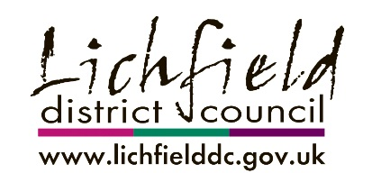

Alrewas Neighbourhood Plan Submission Consultation
Representation Form

Alrewas Parish Council has submitted the Alrewas Neighbourhood Plan 2013-2029 to Lichfield District Council. Under section 16 of the Neighbourhood Planning (General) Regulations 2012 Lichfield District Council are now consulting on the proposed Neighbourhood Plan and would like your comments. In order for your representation to be taken into account at the Neighbourhood Plan examination and keep you informed of the future progress of the Neighbourhood Plan your contact details are needed. The closing date for representations to be made is 16 February 2018 at 17:00pm.

Please return your completed representation forms by the closing date via email to developmentplans@lichfielddc.gov.uk or by post to the following address;
Spatial Policy & Delivery
Lichfield District Council
District Council House
Frog Lane
Lichfield
Staffordshire
WS13 6YY
All comments will be publicly available and identifiable by name and organisation (where applicable). Please note that any other personal information provided will be processed by Lichfield District Council in line with the Data Protection Act 1998.

You can view the Alrewas Neighbourhood Plan and associated documents via http://www.lichfielddc.gov.uk/alrewasnp or hard copies of the documents are available in reception at Lichfield District Council.
Please complete the boxes below using a separate form for each representation:
Name(s):

Name(s) of Organisation (if applicable):

Address (including postcode):

Email address:

Please state whether you would like to be notified of the Council’s decision on the Neighbourhood Plan Proposal:

Yes No

If ‘Yes’ is your preferred method of contact either via email or post?

Email Post
Please state which part of the Neighbourhood Plan (for example which section, paragraph or policy) your representation relates too:

Please use the space below to make comments on this part of the Neighbourhood Plan:

Please continue on separate sheet if required

Please return your completed representation forms by the closing date via email to developmentplans@lichfielddc.gov.uk or by post to Spatial Policy & Delivery, Lichfield District Council, District Council House, Frog Lane, Lichfield, Staffordshire, WS13 6YY

Including amendment regulations; The Neighbourhood Planning (General) (Amendment) Regulations 2015 and The Neighbourhood Planning (General) and Development Management Procedure (Amendment) Regulations 2016.

