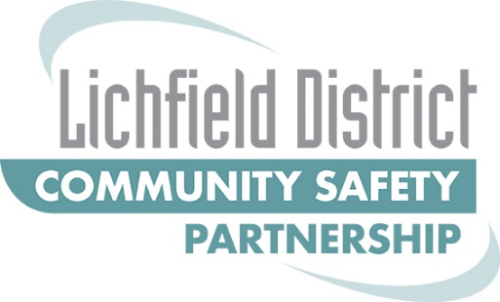
Community safety delivery plan 2022-2025

Contents
Community safety delivery plan 2022-2025 1
Introduction 3
Domestic Abuse 6
What is domestic abuse? 6
Domestic abuse in Lichfield District 6
Lichfield Response 6
Anti-Social Behaviour 8
What is ASB? 8
ASB in Lichfield District 8
Lichfield Response 8
County Lines 10
What is County Lines? 10
Lichfield Response 10
Violence against women and girls 12
What is VAWG? 12
Lichfield Response 12
Other priority areas 14

Introduction
Lichfield Community Safety Partnership is the statutory partnership that coordinates the response to crime and disorder across the District. Hosted within the District Council the partnership consists of a wide range of different agencies and voluntary sector services.
S17 of the Crime and Disorder Act 1998 requires the partnership to do:
“all that it reasonably can to prevent,
(a) crime and disorder in its area (including anti-social and other behaviour adversely affecting the local environment); and
(b) the misuse of drugs, alcohol and other substances in its area and
(c) re-offending in its area”

This delivery plan sets out the partnership response to meet these challenges. In addition the plan takes account of the local priorities and those of the Police, Fire and Crime Commissioner for Staffordshire.
The partnership has considered local crime data and has received contributions from partner agencies. For 2022/23 it has identified that at the heart of its response there needs to be coordination between services to respond to vulnerable people. There are thematic issues which will also be a priority for the partnership, but at its heart we have identified that vulnerability is key. Consequently our delivery plan for the coming year has a clear focus around vulnerable people.
In addition we recognise that the largest volume of calls to our respective services and the most risk and harm that we respond to can be categorised within the following thematic issues:
- Anti-social Behaviour (ASB)
- Domestic Abuse
- County Lines
These are the priority areas that we will seek to deploy resources to either, reduce the incidence, reduce risk and harm or increase resilience.
There are also supplementary thematic issues which remain concerning and which require us to coordinate our responses in a better way. These include our collective response to:
- Fraud
- Modern Slavery
- Business Crime
- Serious and Public Space Violence
- Extremism
- Car Key Burglary and Vehicle Theft
- Hate Incidents and Hate Crime
- Road Safety
- Fire
We also acknowledge that it is vital that we have a clear and unequivocal Lichfield response to the issues faced in respect of Violence Against Women and Girls. It is therefore our intention to further develop our response to this during 2022/23 and this may well underpin some of the specific work that we seek to deliver during the year.
It is recognised that in some of these areas we currently do not share information as well as possible and that we do not have sufficient information currently to assess how the work we are delivering is directly impacting on these issues. For instance although we have access to data from Staffordshire police as to the number of anti-social behaviour reports they receive, we are currently not able to collect similar information from other agencies who work in the district to complement that picture. This therefore will continue to be an area that we will look to develop.
Although this delivery plan is for the Lichfield District area only, we acknowledge that there is a great deal of value of ensuring that we coordinate a response across the county and indeed, across borders to other related locations. So we will work alongside Staffordshire Community Safety Forum and with partnerships and agencies in the West Midlands and beyond where appropriate.
Our main focus is ensuring that we work together with services and partner agencies to provide the best possible customer service to our Lichfield District residents. To enable us to achieve this we hold Partnership Hubs where various agencies discuss issues and concerns and work together in order to come to the best possible outcome.
The Vulnerability Hub is held fortnightly and is focused on vulnerable members of our district which could be individuals or families. Some cases from the Vulnerability Hub may need to be escalated to the Multi Agency Risk Assessment Conference (MARAC), and in turn de-escalated back to the Hub at the appropriate time.
The ASB and Exploitation Hub is also held fortnightly and looks at youth ASB, county lines and risks of exploitation, cases are escalated to the Multi Agency Child Exploitation meeting if appropriate.
Figure one shows how we anticipate the priorities working together with vulnerable people at the heart of everything we do.

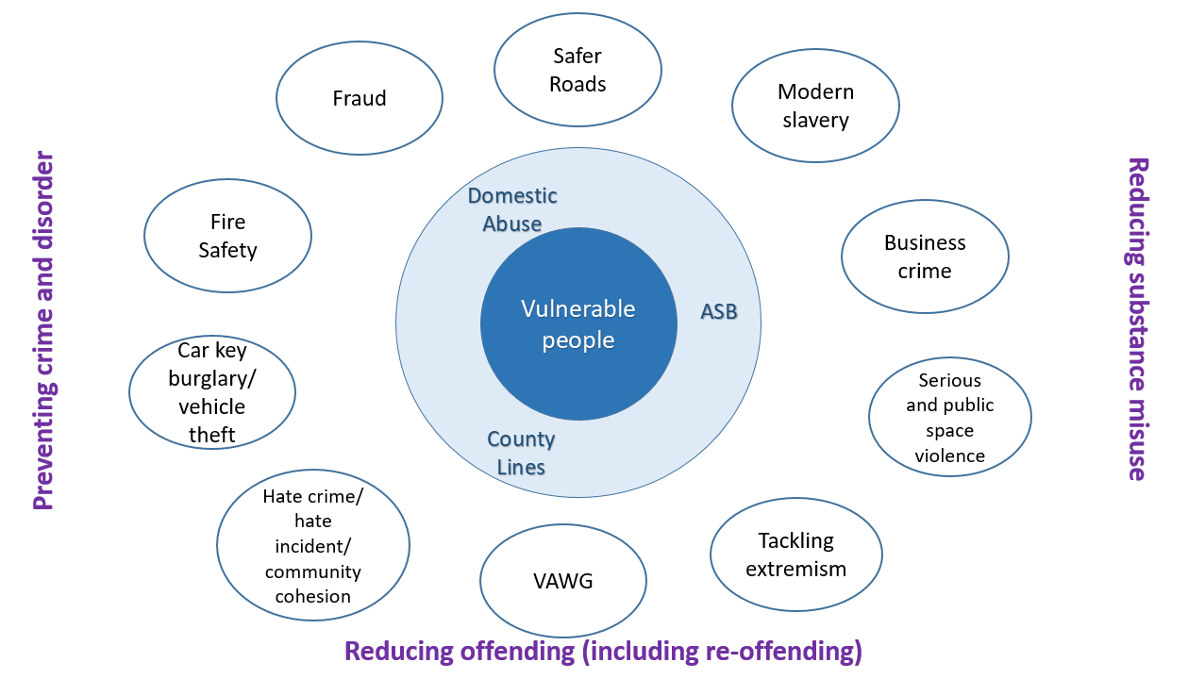
Figure 1

Domestic Abuse

What is domestic abuse?
The UK government’s definition of domestic abuse is “any incident or pattern of incidents of controlling, coercive, threatening behaviour, violence or abuse between those aged 16 or over who are, or have been, intimate partners or family members regardless of gender or sexuality. The abuse can encompass, but is not limited to psychological, physical, sexual, financial, emotional.”

Domestic abuse in Lichfield District
In 2020-21 there were 1,240 DA-related crimes in Lichfield, equivalent to a rate of 11.7 per 1,000 population. This is one of the lowest rates in the force-area. Although crime overall in Lichfield has reduced considerably in 2020-21, DA crime has slightly increased (+5%) with DA accounting for 26% of all crime in the local area. Although the overall rate for Lichfield District is lower than the force average, there are three wards where incidents are higher than the force average. These are Curborough (26.1), Chasetown (22.8), (Chadsmead, 17.9).

Lichfield Response
As a priority, partners need to continue to work together to both support the victims of domestic abuse and to reduce the risk and harm caused by perpetrators of domestic abuse. Our priority as a partnership will be to reduce repeat offenders and victims by raising awareness and encouraging reporting at the earliest opportunity.

Action | Outcome | Data
Further develop the local MARAC | Reduced risk for victims | Number of high risk cases
Develop a MATAC (Multi agency tactical assessment meeting) to target repeat offenders | Reduced incidents perpetrated by repeat offenders | Reduced incidents perpetrated by known offenders
Continue to support victims and their families including children and young people | Reduced incidents of domestic abuse  Increased resilience in survivors and potential victims | % reduction in incidents  % reduction in repeat incidents
Support Operation Encompass at a local level | Earliest intervention and support for children and young people who have been impacted by domestic abuse | Number of contacts with designated safeguarding leads in schools
Raise awareness of how support can be accessed and awareness to perpetrators of what behaviour is unacceptable | Earlier self referral to support agencies  Reduced number of repeat perpetrators | Increased referrals to partner agencies  Repeat perpetrators  Reach of social media campaigns
Targeted awareness raising at schools and youth provision with aim to gain stronger engagement with police and other agencies  Gain understanding of what awareness raising taking place in schools and identify any gaps | Better awareness and resilience amongst young people and more engagement from schools with partnership activity around domestic abuse | Number of sessions held in schools or other youth settings  Number of new opportunities identified
Support local and national campaigns to highlight the impact of domestic abuse | Better awareness of impact and earlier self referral | Increased requests for service  Reach of social media campaigns  Evidence of impact of campaigns (eg Christmas, World Cup campaigns)
Identify when stalking prevention orders and non-molestation orders are required | Reduced risk from stalking and molestation | Number of non-molestation orders supported

Anti-Social Behaviour

What is ASB?
Anti-social behaviour (ASB) is a broad term used to describe the day-to-day incidents of crime, nuisance and disorder that can make people’s lives a misery – from litter and vandalism, to public drunkenness and abusive neighbours.

ASB in Lichfield District
In 2020-21 there were 3,460 ASB incidents in Lichfield, equivalent to rate of 32.8 per 1,000 population. This is lower than the force-wide rate (41.0) and rates for England and Wales. ASB recording for 2020-21 includes incidents of recorded Covid-19 legislation breaches, which accounted for 1,455 incidents or around 42% of recorded ASB in Lichfield.
While rates of ASB in the CSP area overall are low, there are some hotspot areas – particularly around Lichfield centre (Stowe ward) and Chasetown.
The proportion of ASB which relates to Neighbour Disputes (27%) is higher than that recorded across the force-area (21%).

Lichfield Response
The Community Safety Partnership are to work together to manage the impact anti-social behaviour is having, or is likely to have, on victims and communities. We can do this by working together in partnership, sharing knowledge, and using the legislation available to services.
The actions set out below will drive closer cooperation between agencies that respond to anti-social behaviour and seek to provide better and more enduring solutions to those who are suffering from anti-social behaviour.
Action | Outcome | Data
Agree an initial single agency response to complaints across partner agencies | Better understanding of issues across the partnership | Number of complaints with multi agency response
Develop a triage process | Reduced duplication of work by partner agencies  More holistic response to complaints  Increased satisfaction of service users | Number of cases discussed and triaged
Develop a process to deal with repeat and perpetuating cases | Reduced number of repeat and perpetuating cases | Number of repeat cases  Number of cases held more than 90 days
Utilise support services such as Harmony | Support provided to people who have experienced ASB | Number of people referred to the services
Fund diversionary activities | More potential victims and perpetrators supported to divert away from ASB | Number of participants engaged in diversionary activities Number of people referred to diversionary services
Deliver training for partners around ASB complaint management and dealing with community triggers | Shared understanding of good practice  Reduced number of repeat complaints  Increased satisfaction of service users | Number of attendees  Attendees reporting improved understanding of good practice

County Lines

What is County Lines?
The National Crime Agency define County Lines as being “where illegal drugs are transported from one area to another, often across police and local authority boundaries (although not exclusively), usually by children or vulnerable people who are coerced into it by gangs. The ‘County Line’ is the mobile phone line used to take the orders of drugs.

County Lines in Lichfield District
The risk of criminal exploitation of vulnerable people exists in every area in Staffordshire and the risk is no less in Lichfield District. Those at particular risk of being criminally exploited are vulnerable people who are generally those who are socially isolated particularly those with mental health needs and learning difficulties or with alcohol or drug dependencies. Children who live in areas with high levels of domestic abuse or in areas of high deprivation are also a group at risk of exploitation as well as young males in care or attending pupil referral units. The recent covid pandemic has exasperated some of these risk factors by increasing social isolation and contributing to a decline in mental health for some. Bourne Vale is the ward in Lichfield with high rates of drug possession which can be indicative of those at risk of involvement with county lines activity. Chasetown has particularly high rates of children subject to child protection plans which may result in children and young people being at risk of criminal exploitation.

Lichfield Response
In Lichfield the risk of exploitation by people involved in County Lines is clear and present. Drugs are being brought into Lichfield and there are existing networks that enable their distribution. The partnership needs to increase resilience of children (in particular) and families to the risks of exploitation and to develop better cooperation between agencies to enable earlier identification of those who are becoming at risk of exploitation.
Action | Outcome | Data
Further develop the early identification and intervention work through partnership HUB meeting including a process for escalation and de-escalation to and from Multi-Agency Child Exploitation (MACE) panel | Children and young people identified at the earliest opportunity for preventative support  More vulnerable people provided ongoing support after intervention by MACE to ensure gains are secured | Number of children and young people considered at partnership hub meetings held  Number of cases through escalation and de-escalation processes  Number of vulnerable people receiving ongoing support?
Refine and review the understanding of the numbers involved or at risk of being involved | A clearer picture of the risks and associated harms to vulnerable people in the district and an increased ability to design and target support | Numbers identified as involved or at risk of county lines from a range of agencies  Examples of design and targeted supports
Identify suitable educative programmes for schools and the PRU to build resilience and raise awareness in targeted cohorts where risk has been identified | Vulnerable young people more resilient to involvement in exploitation | young people in the targeted cohorts engaging in educative programmes
Deliver awareness raising information for taxi drivers and local venues such as hotels | Increased awareness and reporting of suspicious activity resulting in better protection for young and other vulnerable people | Number of people attending training  Numbers attending reporting an increased understanding of issues and awareness of how to report

Violence against women and girls

What is VAWG?
Violence against women and girls (VAWG) is an umbrella term used to cover a wide range of abuses against women and girls such as domestic homicide, domestic abuse, sexual assault, abuse experienced as a child, female genital mutilation (FGM), forced marriage and harassment in work and public life. While men and boys also suffer from many of these forms of abuse, they disproportionately affect women.

VAWG in Lichfield District
While a proportion of violent offences experienced by women and girls in Staffordshire and Stoke-on-Trent are domestic-related, a considerable amount are not. In the 12 months to October 2021, while non-domestic violent offences with a victim of any sex saw no change on the previous year (+/- 0%), non-domestic violent offences with a female victim increased by around 7% in the same period.

Lichfield Response
The Community Safety Partnership will support Staffordshire Police’s Action plan around VAWG by focusing on the two areas of prevention and engagement/safety in public. This will include tackling all forms of discrimination, including that against women and girls and challenging language and behaviours to enact cultural change. We will consider the safety of women and girls when designing public spaces and activities.
Action | Outcome | Data
Challenge attitudes and behaviours in relation to VAWG linked to the government’s ‘enough’ campaign. | Greater community awareness of problematic behaviours and how to address them | Evidence of media campaigns and reach
Develop safer public spaces with the intention to reduce risk and reduce threatening male behaviour. Use and promote the Streetsafe tool to identify problem areas. | Reduced risk to women and girls in public spaces | Evidence of consideration of safety of women and girls in public space design  Increased number of reports via Streetsafe tool
Work with public transport providers to understand awareness of VAWG and measures that can be put in place | Improved safety for women and girls on public transport | Measures put in place
Provide information and support for licensed premises around the potential for violence against women and girls and preventative measures | Reduced risk to women in the night time economy | Evidence of initiatives carried out
Work alongside Safer Streets and the Safer Nights initiatives | Reduced VAWG in public spaces and night time economy | Number of safer nights initiatives
Assist in the development of targeted activities for girls at risk | Increased activity, improved mental health and reduced isolated of targeted girls | Number of girls actively engaged in activities  Number of referrals to the activities  Self-evaluation of attendees
Consider specific opportunities to engage with men and boys to be part of the solution to end violence against women and girls linked to the government’s ‘enough’ initiative. | Increased awareness of the impact of behaviours and changes in behaviours | Number of boys and men engaged with activities and campaigns

Other priority areas
The partnership response to these areas will mainly focus on awareness raising and signposting to support services where appropriate. The partnership will consider the target demographic for publicity materials and present these in a variety of formats where necessary to ensure the messages reach the widest possible audience.
The partnership is also keen to develop a joint communications plan to avoid duplication of campaigns, share resources, standardise messaging and increase the impact of campaigns.
Action | Outcome | Data
Signposting for specific assistance and promoting campaigns | Local residents better able to access county wide and national services and have increased awareness of the support services available | Number of shares of county wide and national media posts and Lichfield reach  Number of campaigns shared in a variety of media  Number of Lichfield residents signposted to support services
Support county wide awareness raising activity and distribute in a range of media taking into account the demographic of the District and vulnerable groups not always served by online content | Increase local reach of county wide and national campaigns | Number of shares of county wide and national media posts and Lichfield reach  Number of campaigns shared in a variety of media
Develop a partnership communication plan | Single, shared messaging across the partnership with the widest possible reach | Number of interactions on social media  Increased referrals to services as a result of campaigns

Crime and Disorder Act 1998 (legislation.gov.uk)

