Safeguarding Children
and Adults at Risk of Abuse and Neglect

How do I find out more about safeguarding?

You can find out more by:

- Completing the required safeguarding courses for your role
- Reading the Safeguarding Policy and Procedure
- Looking at the safeguarding area of Brian (the intranet)
- Checking the flow charts for raising concerns (in the procedure and
available on Brian)
- Speaking to the Designated Safeguarding Officer, or the Deputy Designated Safeguarding Officers
- Looking at the following websites:

learning.nspcc.org.uk/safeguarding-child-protection www.barnardos.org.uk/what-we-do/protecting-children wearehourglass.org/england
www.mencap.org.uk/advice-and-support/safeguarding/safeguarding-adults

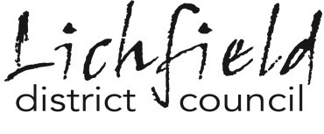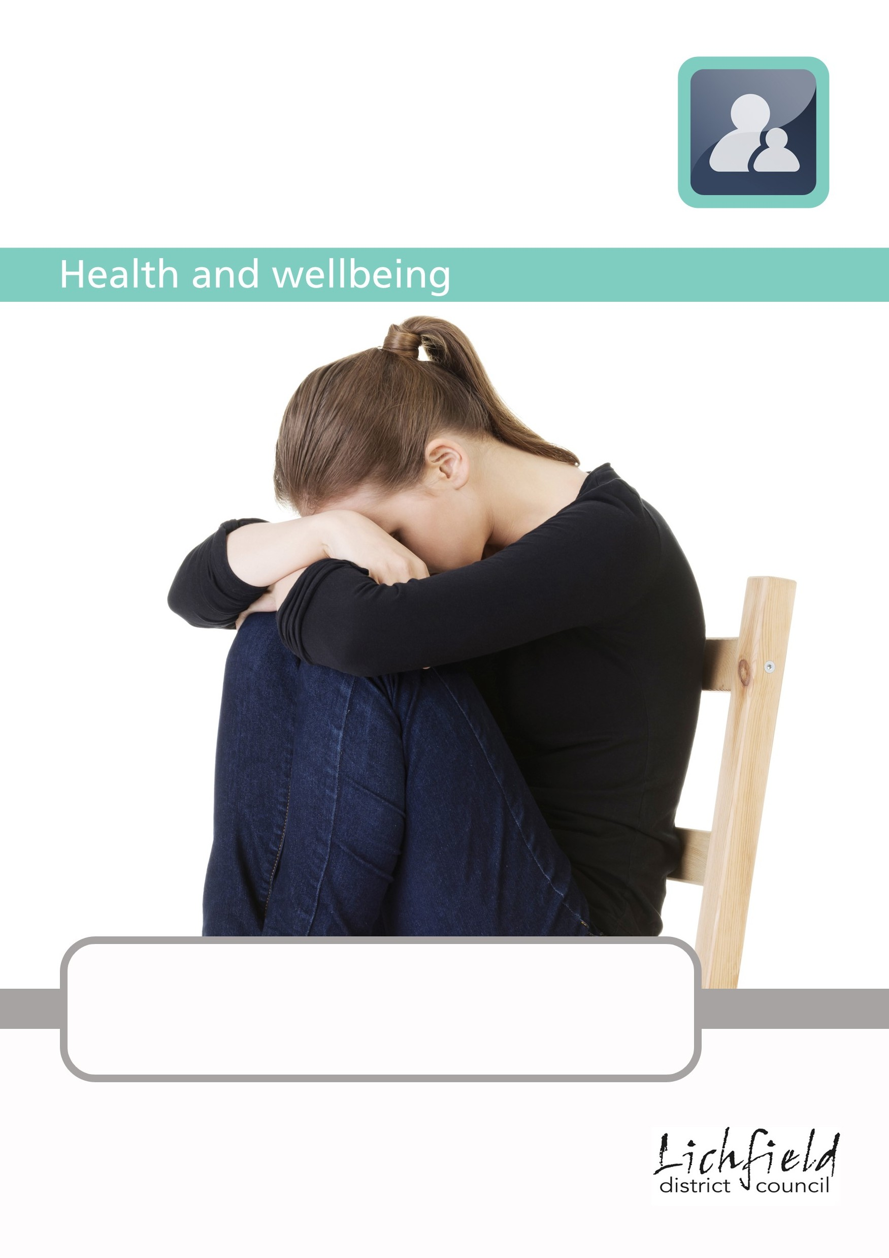More information is available on the ‘Safeguarding’ section of Brian.

xx
xx xx xx
• xx
• xx
• xx

xx

Issue number: 1

www.lichfielddc.gov.uk/housing

Updated November 2022

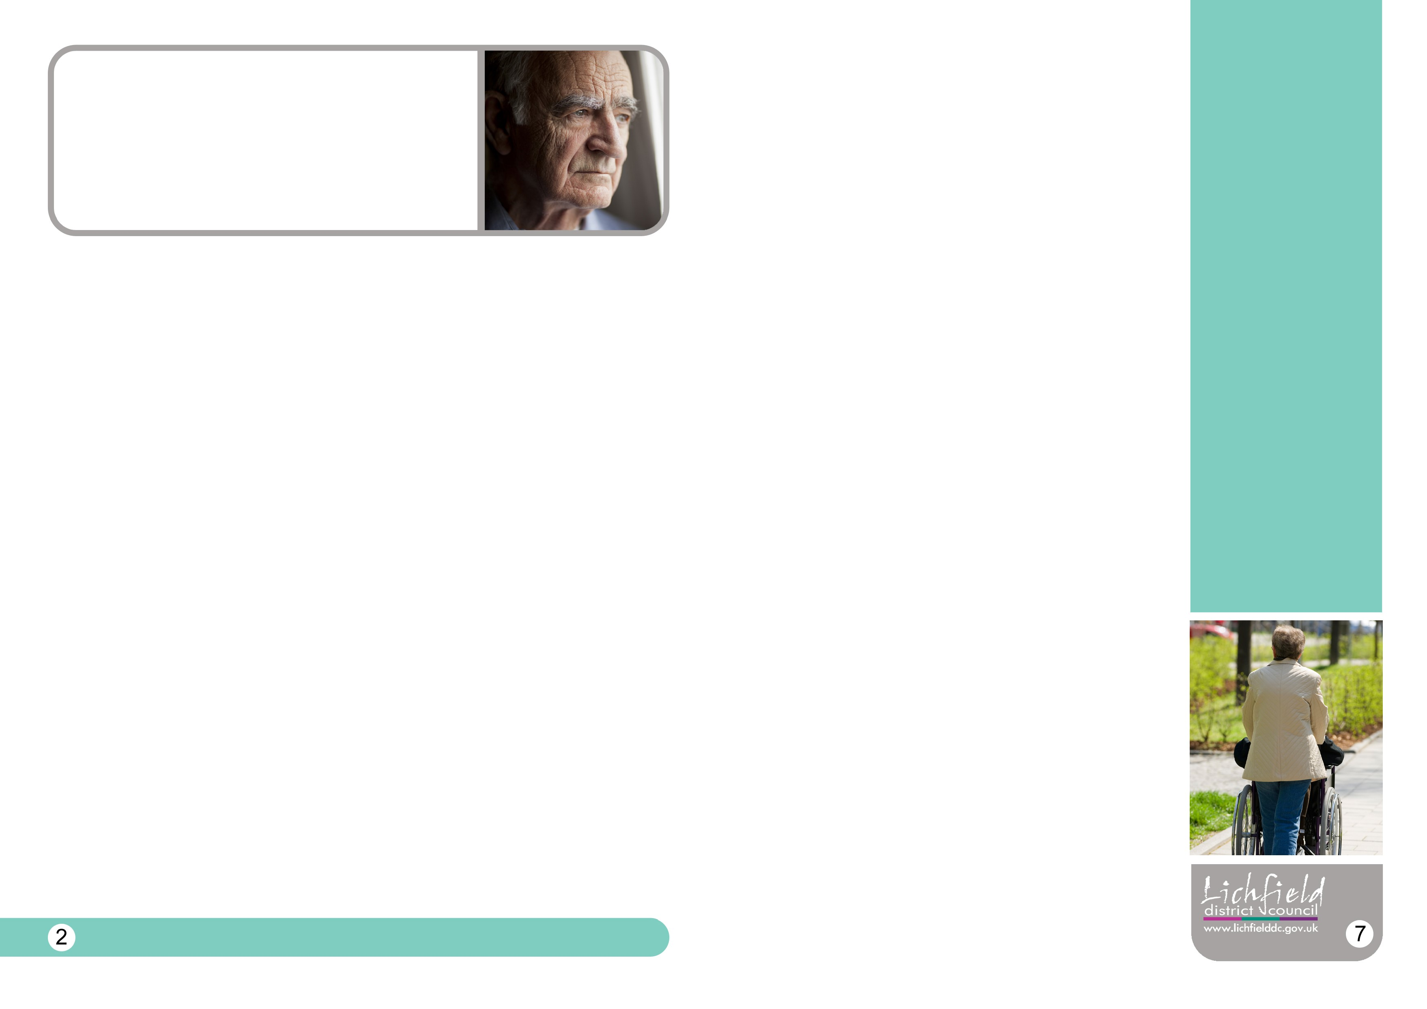
Safeguarding is everyone’s responsibility

What is safeguarding?
Essentially, safeguarding means protecting children and adults at risk from ill-treatment and harm.
Children are anyone who is under 18 years of age. Adults at risk have:
- Care and support needs (whether or not the local authority is meeting any of those needs) and;
- are experiencing, or at risk of, abuse or neglect; and
- as a result of those care and support needs are unable to protect themselves from either the risk of, or the experience of, abuse or neglect.

Lichfield District Council has a legal and moral responsibility to safeguard and promote wellbeing and protect children and adults at risk.

This leaflet gives you more information about:
- types of abuse and signs to look out for
- what to do if you have any safeguarding concerns
- what to do with welfare and wellbeing concerns
What if I have a welfare concern about an adult at risk?

The Staffordshire Cares team may be able to offer advice and help if you are concerned about someone with care and support needs. You should make the family aware if you are making a request for support and where possible get their agreement.

Tel: 0300 111 8010
Emergency out of hours: 07815 492613
Email: staffordshirecares@staffordshire.gov.uk

If you have a concern about the mental health of an adult you can contact the Lichfield & Burntwood Community Mental Health Team (CMHT) on 0300 555 5001.

You can also speak to Yvonne James on 01543 308777 or Stuart White on 01543 308005 about whether the concerns should be shared with partners at the Partnership Hub meeting.
Any concerns must be shared with the Designated
Safeguarding
Officer

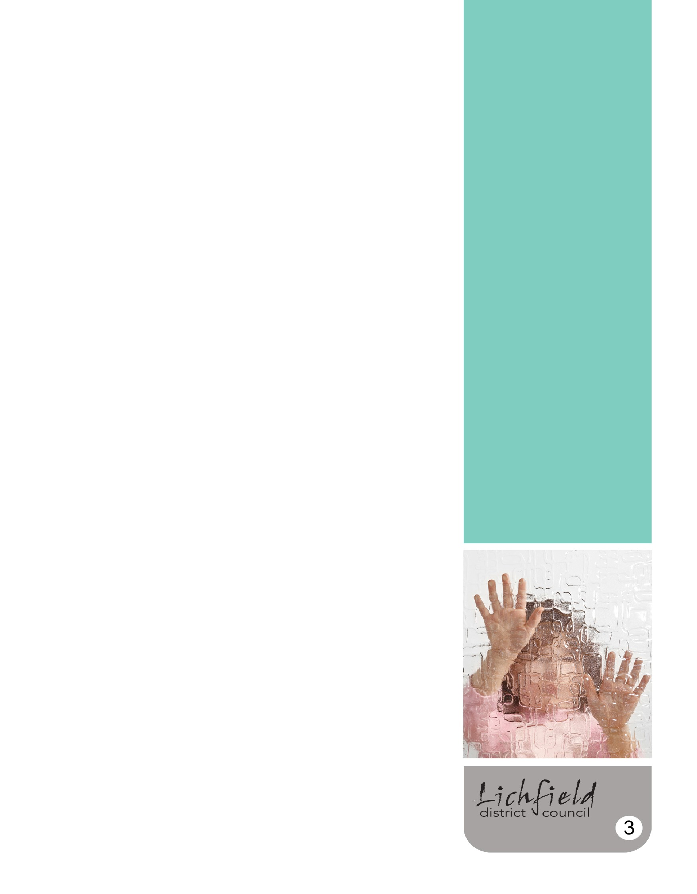
Designated Safeguarding Officer: Christie Tims
Tel: 01543 308002

What if I am not sure about whether my concerns are a
safeguarding issue?

You may be concerned about a child or adult at risk but are unsure if they are at risk of harm from abuse. It is likely to be a safeguarding issue if you have a serious concern about the safety of a child up to the age of 18 or an adult with care and support needs and think they are being harmed or at risk of being harmed.

If you are unsure if your concerns are a safeguarding issue you can talk to the designated Safeguarding Officer in the first instance. Any member of leadership team will also be able to offer advice.

What if I have a welfare or wellbeing concern about a child or young person?

The Early Help team may be able to advise if they are already working with the family or can offer help. You should make the family aware if you are making a request for support and where possible get their agreement.

More information is available at www.staffsscb.org.uk/early or by calling 0300
111 8010.
What is my role?
As councillors, council employees and volunteers, we may go into people’s homes, deliver services to children and adults at risk, or we may notice something that concerns us when we are out.

It is not our role to investigate any signs of abuse. However, we have a responsibility to act if we have concerns and alert those who can look into the issues.

As individuals we may think we are unlikely to come across any signs of abuse, but if we understand what to look out for, we are better placed to pick up on indicators and behaviours, if we come across them.

What do we mean by abuse?
Abuse, including neglect, are forms of ill treatment and harm. Somebody may abuse a child or adult by inflicting harm, or by failing to act to prevent harm. It can happen to men, women and children and in many different places. It is carried out by different people, but it's often someone known and trusted.

The most common types of abuse are physical, emotional, sexual, and neglect. Other forms of abuse include self-neglect (for adults), financial, discriminatory abuse and organisational abuse.

Domestic violence, child sexual exploitation, forced marriage, hate crime, female genital mutilation, modern slavery and bullying are other forms of abuse.

Safeguarding children and adults at risk from being drawn into county lines, violent extremism and/or terrorism is also a safeguarding issue. More information is in the Safeguarding Procedure, on Brian or from the designated Safeguarding Officer.

It is important to act immediately if you suspect someone
is being harmed or abused

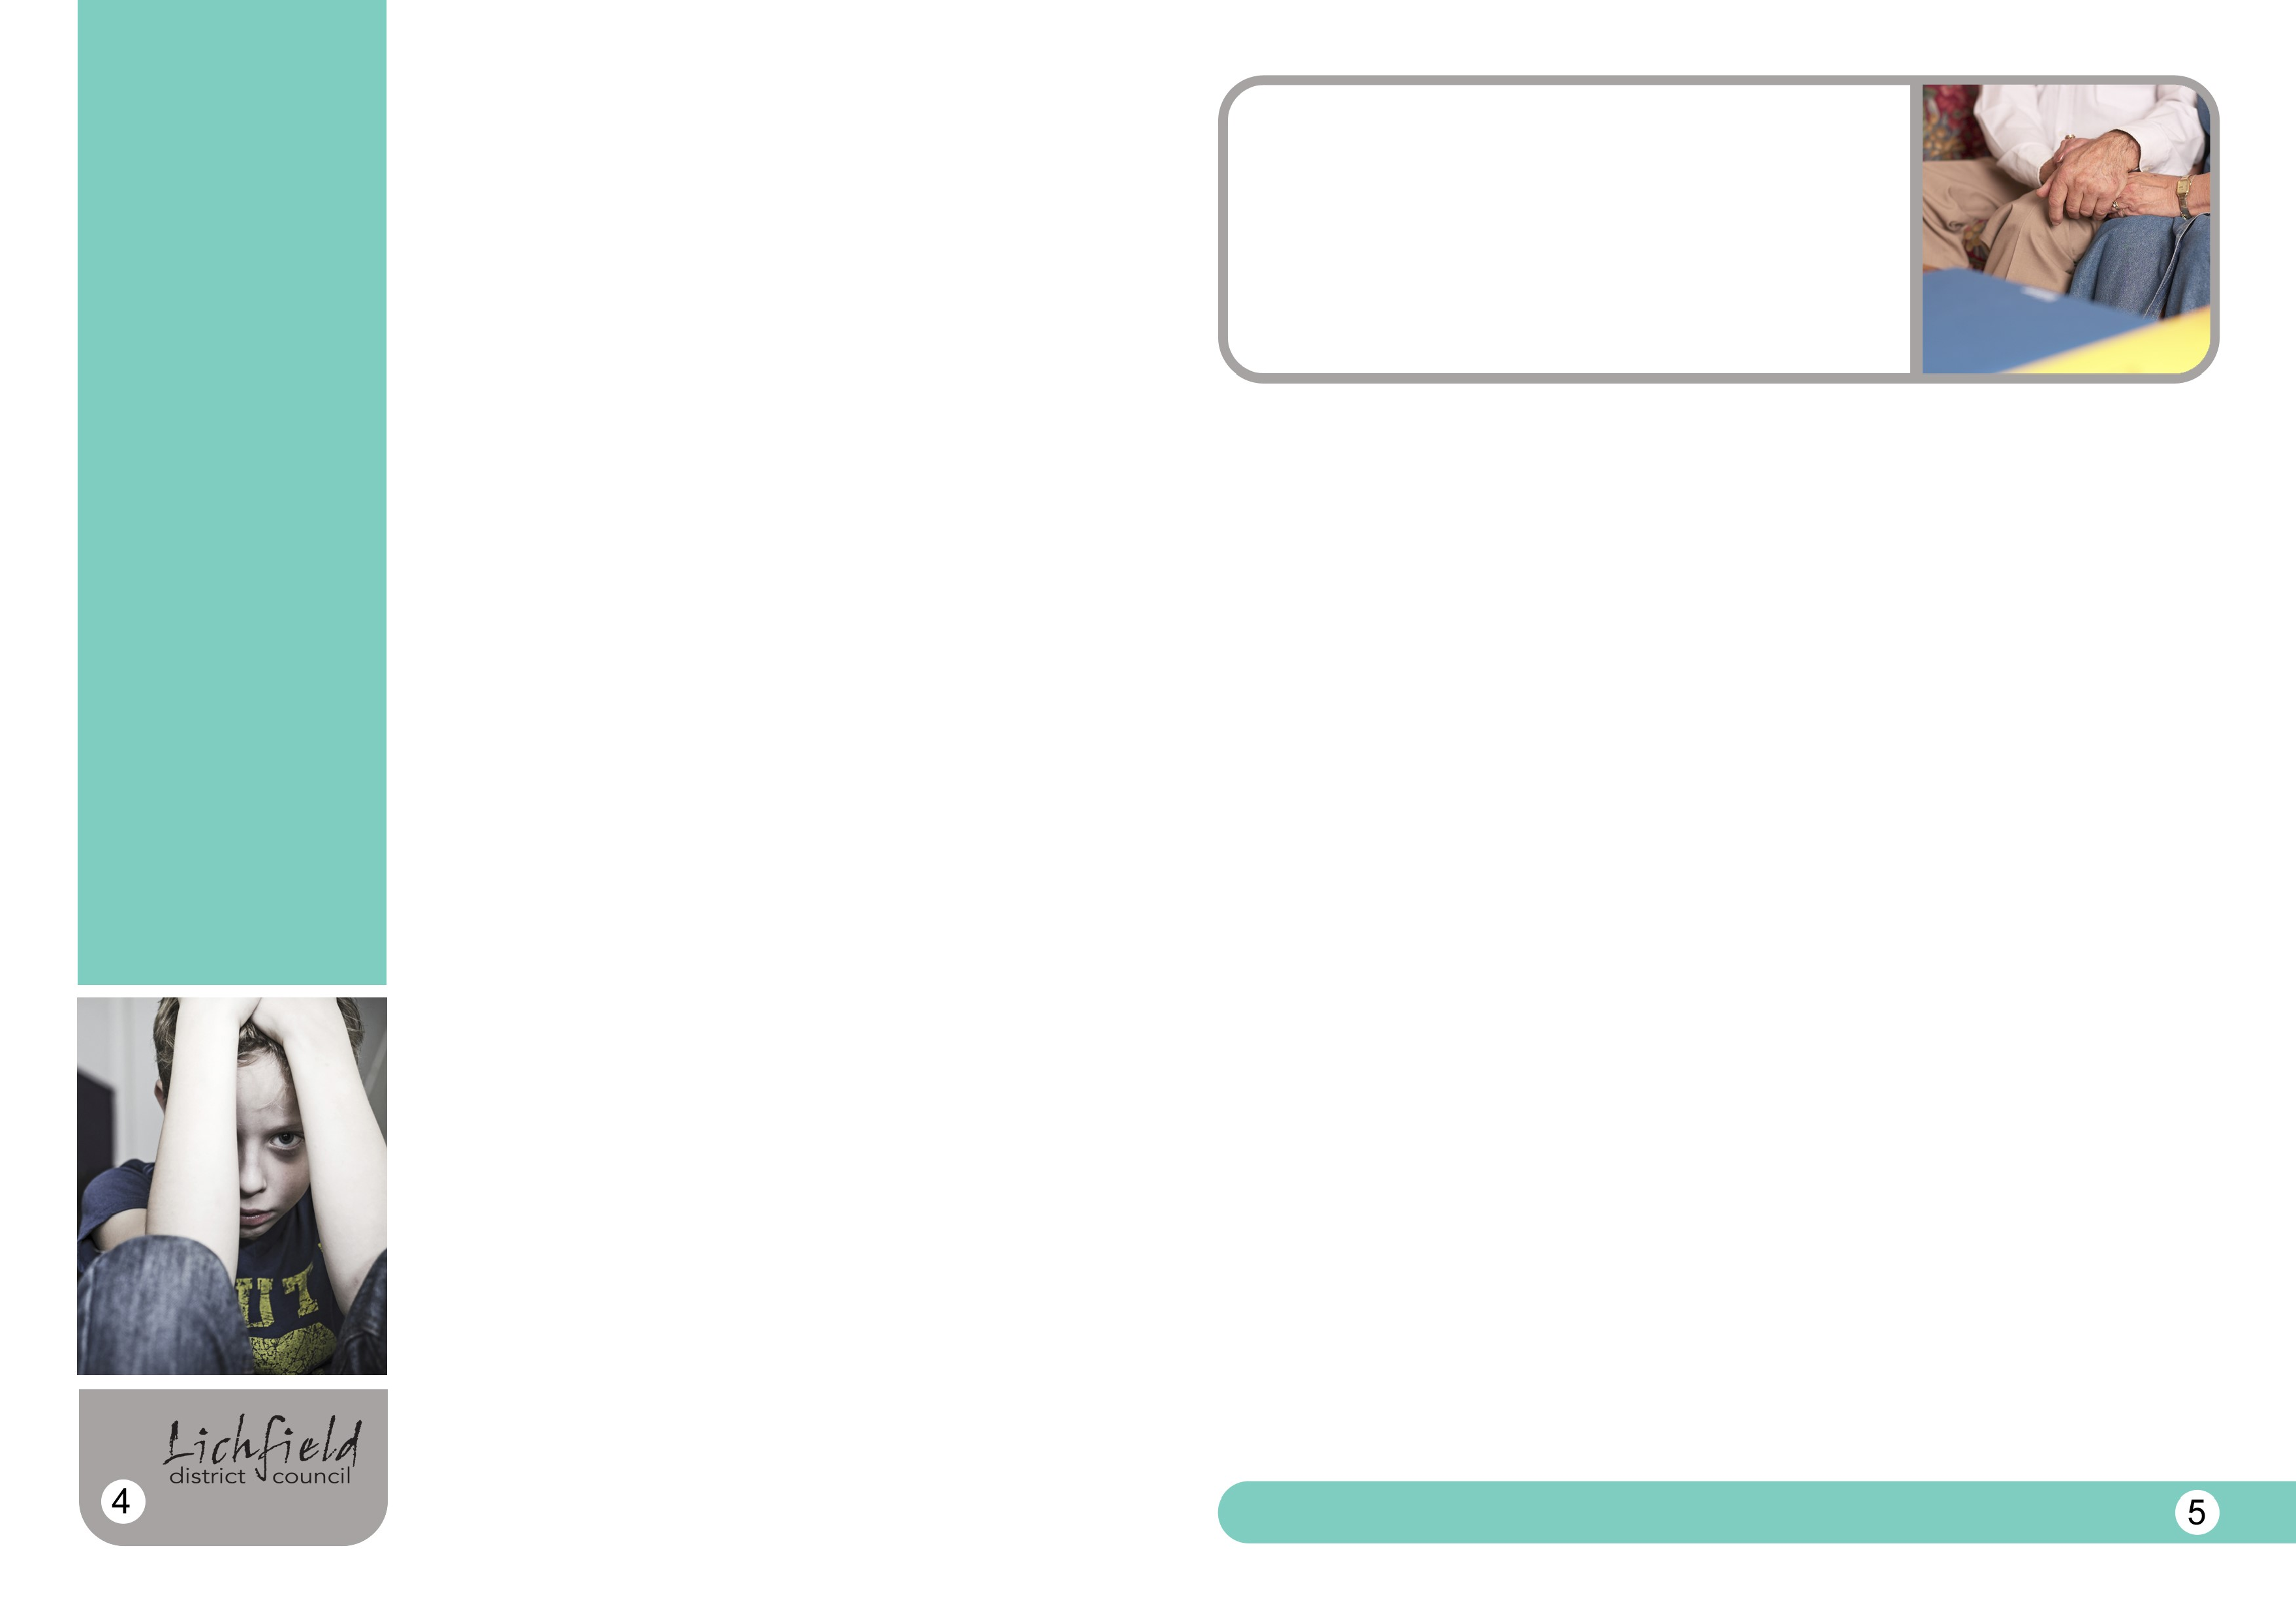Being aware of indicators may help identify that abuse could be taking place

More information is available on the ‘Safeguarding’ section of the intranet

What should I look out for?
Indicators that a child or adult at risk may be experiencing abuse could include the following:
- Unexplained or suspicious injuries such as bruising, cuts or burns, particularly if on a part of the body where such injuries are not likely to have happened accidentally.
- An injury where the explanation seems inconsistent.
- Unexplained changes in mood and behaviour - becoming very withdrawn, secretive and/or having severe temper outbursts.
- Going missing.
- Fear and distrust of adults, particularly when a close relationship would normally be expected.
- Inappropriate sexual awareness and/or sexually explicit behaviour.
- Difficulty in making friends.
- Acquiring money or expensive gifts that can’t be accounted for.
- Recent acquaintances showing sudden or disproportionate interest in the child or adult.
- Unexplained shortage of money and/or withdrawals from the bank.
- Being prevented from socialising with others.
- Variations in eating patterns including overeating or a loss of appetite.
- Weight loss for no apparent reason.
- Noticeable changes in appearance.
- Becoming increasingly dirty and unkempt.
An at-risk child or adult may also describe an act involving them which appears abusive or someone else may express concerns about a child or adult at risk.
These are indicators and do not mean abuse is or has been taking place. For signs against each type of abuse please refer to the Safeguarding Procedure.

What should I do if I have any concerns?
If you believe a child or adult is at risk of immediate harm or needs medical
attention phone 999 and report the incident to the police.
If you believe a child or adult at risk is being harmed or at risk of harm, you should contact Staffordshire Social Care on the numbers below.
Don’t assume that someone else will report it, they may not .

Children and young people
Staffordshire Children’s Social Care’s First Response Team: 0800 131 3126 (between 8.30am and 5pm and 4.30pm on a Friday).
Outside these hours call Staffordshire County Council Emergency Duty Service on: 0345 604 2886

Alternatively email firstr@staffordshire.gov.uk with your contact details. Do not include any confidential details about a child or young person.

Adults at risk
Adult Protection Team Contact Centre: 0345 604 2719 (between 8.30am and 5pm and 4.30pm on a Friday). Outside these hours call: 0345 604 2886
Alternatively email VAStaffordshire@staffordshire.gov.uk with your contact details. Do not include any confidential details about an adult at risk.
All concerns must be shared with the designated Safeguarding Officer Christie Tims (01543 308002) or the deputies Lucy Robinson (01543 308710) or Sarah Sleigh (01543 308772), so we have a record of all concerns raised.
Referrals can be made using the above contacts, but you also need to complete the form for reporting concerns, which is available on the intranet. The Designated Safeguarding Officer or deputies can make a referral on your behalf if necessary, but it is generally better if you make the referral yourself because you will be able to directly feedback your concerns.
More information is available in the Safeguarding Children and Adults at risk of Abuse and Neglect Procedure.

