

Knife Angel in Lichfield, Staffordshire
July 2023
Post Engagement Appraisal

1

Foreword
The Lichfield District Community Safety Partnership co-ordinated 30 days of educational workshops and engagement activity in the district, alongside numerous partners. Children and young people, local residents, community groups, partners and visitors to the area were all invited and encouraged to take part. Key prevention, anti-violence and anti-aggression messages were shared throughout the month, allowing people, and importantly, young people, to stand up against violence and aggression in all forms, not just knife crime.
Whilst we have seen an increase in knife crime in the West Midlands over the last decade, the Knife Angel was not brought to Lichfield because of any major problem with this kind of crime in the area. However, we must not be complacent, and our hope as a Partnership is for our communities to remain safe and that we take a preventative approach in reducing crime over the long term.
The Knife Angel assisted in raising critical awareness of knife crime whilst creating a widespread intolerance to violent behaviour within our communities. We want all residents and visitors to see Lichfield District as a safe place to live, work, visit and study, and I want our youngsters to feel safe and secure. Any form of violence and aggression will not be tolerated.
We are proud about what we have been able to achieve this summer with the Angel’s visit to Frog Lane.

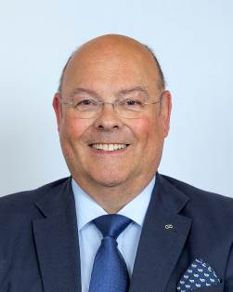

Councillor Richard Cox
Portfolio Holder for Community Engagement

Introduction
The Knife Angel arrived in Lichfield on 30 June 2023, in readiness for a month-long visit to the district. The Knife Angel, created by the British Ironwork Centre in Shropshire, is touring the UK in a bid to raise awareness of how knife crime affects communities, families, and individuals. The Centre launched their ‘Save a Life, Surrender Your Knife’ campaign during 2015/2016, working with the Home Office and police forces to conduct knife amnesties to collect the material needed for the statue. Artist Alfie Bradley first created the structure out of steel before welding knives, which had been disinfected and blunted, to create the feather- like appearance of the Angel. Over 100,000 knives were used to create the sculpture, all collected by the knife amnesties, including some knives involved in crime.

The sculpture, standing at 8 metres tall, recognises those whose lives have been blighted by knife crime and acts as a memorial for bereaved
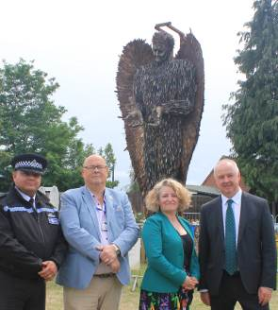

families. The Centre worked closely with numerous charities and families affected by knife crime and violent crime to raise awareness of the devastating impact of knife crime. The Centre also invited the families of those lost to knife and violent crime to engrave messages on the blades to be included on the monument.

To share the Knife Angel’s key messages of prevention, anti-violence and anti-aggression, a month-long programme of engagement activity was established. This report provides further detail on the engagement activity undertaken, as well as the impact felt by those who visited the Knife Angel and
From left to right: Chief Inspector Matthew Morgan, Councillor Richard Cox, Christie Tims and Ben Adams, Staffordshire PFCC.
who were involved in this project.

Governance
In early 2023 the Community Safety Partnership were offered the opportunity to host the Knife Angel following it’s visit to nearby Nuneaton in June. Together with the British Ironworks Centre, the Community Safety Partnership and the Police, Fire and Crime Commissioner (PFCC) ensured that the Angel made it safely to Lichfield District at the end of June 2023.
The planning for the Angel’s visit was conducted by LDC officers, in conjunction with various partners from Staffordshire Police and Staffordshire Fire Service.
The Community Safety Partnership has a statutory duty to address certain key issues detailed within the Community Safety Action Plan.
The Knife Angel Campaign was considered to be an appropriate vehicle to raise awareness of multiple key priorities within the delivery plan:
- Domestic Violence
- Anti Social Behaviour
- County Lines
- Serious Violence Duty
- Crime Prevention
Funding for the Knife Angel has been provided by the PFCC via the Lichfield District Community Safety Partnership.
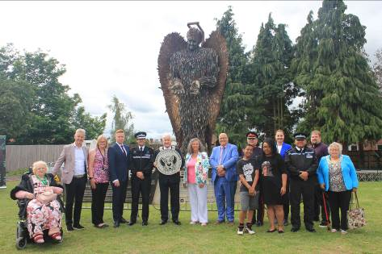
From left to right:
Cllr Kathy Coe, Clive Knowles - Chairman of the British Ironwork Centre, Yvonne James – Principal Community Safety Officer Lichfield District Council, Cllr Doug Pullen, Leader of LDC, Chris Noble, Chief Constable of Staffordshire Police, Cllr Derick Cross, Chair of LDC, Helen Fisher, Deputy Police Fire and Crime Commissioner, Cllr Richard Cox, Deputy Lieutenant James Leavesley, Cllr Selena Mears, Cllr Dave Robertson, Cllr Diane Evans,
At Front :
Rapper Harvster and his mother and Chief Insp Matthew Morgan.

Arrival
The Knife Angel arrived in Frog Lane on the morning of 30 June 2023, after a short journey from Nuneaton. The Knife Angel was erected on open space next to the District Council House on Frog Lane where it stood proudly for the month of July. This was an ideal location for residents of, and visitors to the town, close to the bus and train station to allow easy access.

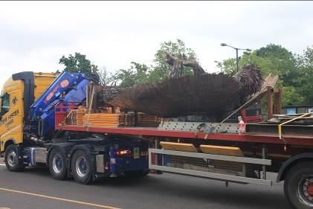
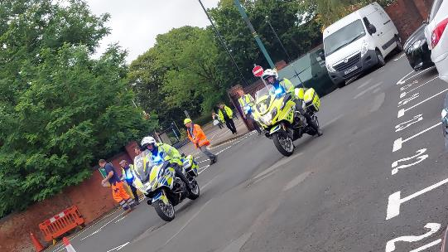
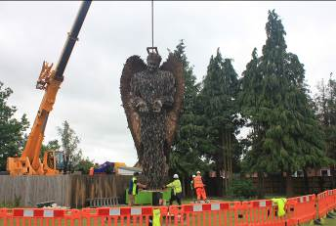

Opening Ceremony
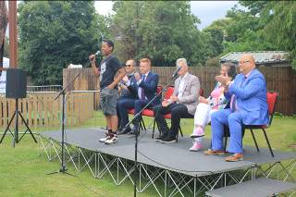

The Opening Ceremony was held on the morning of Saturday 1 July. Key community representatives and partners were all invited to attend, and being in a public place, the Ceremony was open to the public.

Attendees heard from those impacted by knife
Crime including Danny Monteith from Streetwhyze
who discussed the murder of Oliver Freckleton,
Paula Reynolds whose son was attacked and scarred,
and Natalie Quiroz who was stabbed whilst 8 months
pregnant by her ex-partner in Sutton Coldfield,
fortunately, both survived their ordeal.

Civic awards were given to Clive Knowles – Chairman of British Ironwork Centre
- Police Crime Commissioner
- Councillor Richard Cox as Cabinet Member
- Community Safety Partnership
- Alison Cope – campaigner for youth violence prevention, mother of knife crime victim
- Kristy and Rob Freckleton - parents of a knife crime victim who live in Burton, who campaign to tackle knife crime
- Beverley and Mark Brindley – parents of a knife crime victim who campaign to tackle youth violence

Individuals of all ages attended the Opening Ceremony, hearing from the speakers who highlighted the importance of the Knife Angel’s visit, along with key anti-violence and anti- aggression messages. Attendees were noticeably in awe of the Angel and how and why the sculpture had been created, when hearing from Clive Knowles.

During the Ceremony, Clive Knowles presented Lichfield District with the National Anti- Violence Charter. The Anti-Violence Charter is a plaque which is supplied by the British Ironwork Centre. The plaque is issued to commemorate the host city/ town being an advocate

of anti-violence and for them taking the pledge to renounce violence in all its forms. The plaque was created to recognise the host’s unrelenting efforts as a National Anti-Violence Charter, as they continue the efforts and programme to educate their youth.

Following the Ceremony, several speakers and attendees were interviewed by the media, whilst the Commissioner’s team engaged with partners and the public in relation to the Angel and the upcoming engagement activities.

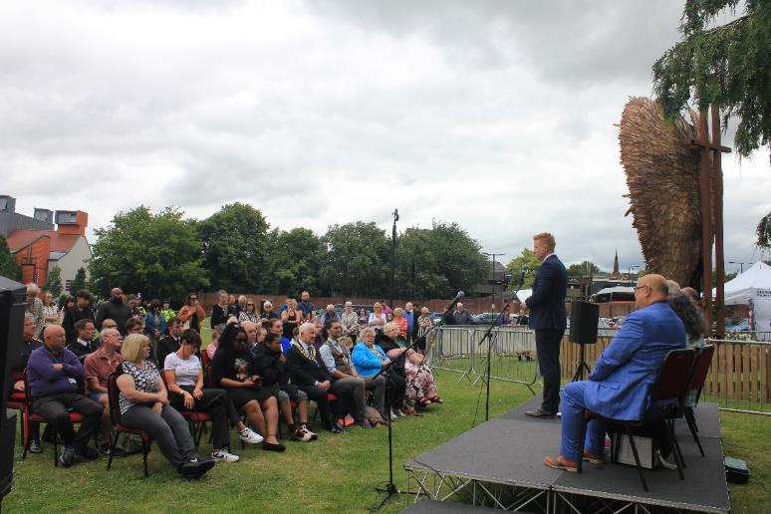
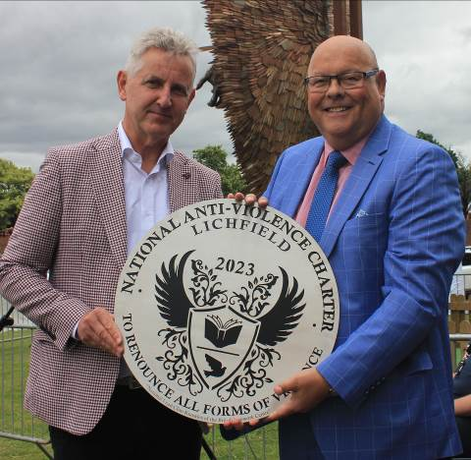
Chairman of the British Ironwork Centre Clive Knowles with Cllr Richard Cox who accepted the plaque on behalf of Lichfield District.

Engagement programme
With assistance from numerous partners, the Principal Community Safety Officer developed an Engagement Programme for the month. The Programme was updated and added to as the weeks went by, with interest around the project growing and requests for involvement being submitted.

During the month there was considerable activity on the Knife Angel site where the Community Safety Partnership gazebo was set up and maned on a daily basis. At the gazebo activities were available which included Emergency Services related colouring in sheets and wordsearches, leaflets with facts and information around the Knife Angel and activities planned in July, pledge cards for the public to write messages on and attach to the fencing surrounding the angel, and the Knife Angel trail sheets.

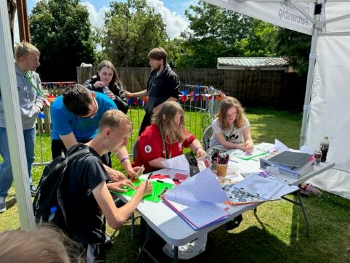
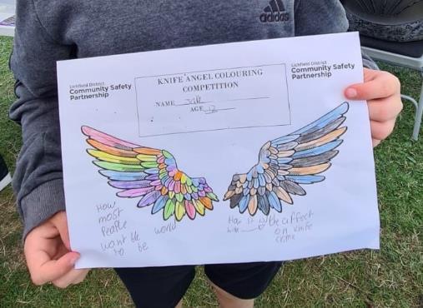

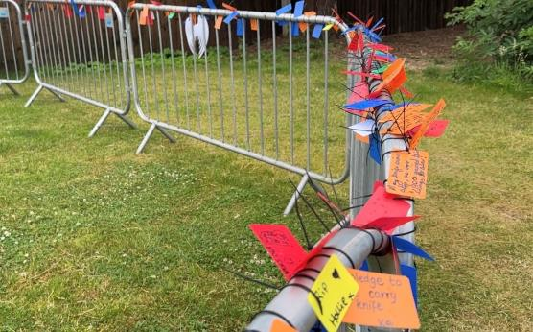
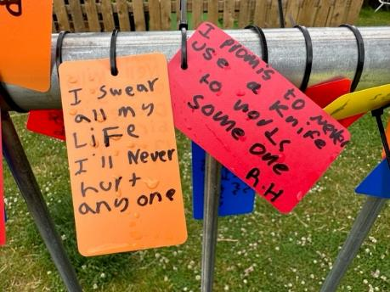

Schools were contacted and all invited to book sessions for class groups to attend the site to see the Knife Angel and for education, this was done by a link that each school received via email, which took them to an online booking system where they could book as many slots as they wished and state how many pupils were going to attend and what transport they would be using.

On arrival the schools were greeted by a member of the Community Safety Partnership and were shown over to the Angel. The schools were given the option to do Knife Angel Quizzes where they would break off into groups and compete to who would get the best score.
They would write their messages and tie them to the fencing, take away wordsearches and colouring to do back at school and also each pupil would be offered a Knife Angel Anti Violence Champion sticker.

The Community Safety Partnership funded Alison Cope to run assemblies in District High Schools to which six schools accepted. These assemblies were very well received and were followed by a PSHE programme set up by Natalie McGrath the PSHE Coordinator for Staffordshire.

“Wow! It was the most emotive and impactful talk I’ve ever listened to. It had such an effect on the students we were able to cram into the theatre.
Thank you so much for supporting with the funding for this. It was worth every penny.
Thanks again”
Chris Briggs
Erasmus Darwin Academy

“Nothing but good feedback from CTA, excellent and very much worthwhile, thank you”
Martin
Chase Terrace Academy

Throughout the month different activities were held on site including talks from Streetwhyze and Mr and Mrs Freckleton, Public Outreach Days, CPR Awareness Day, Pride Day and Air Ambulance Days.

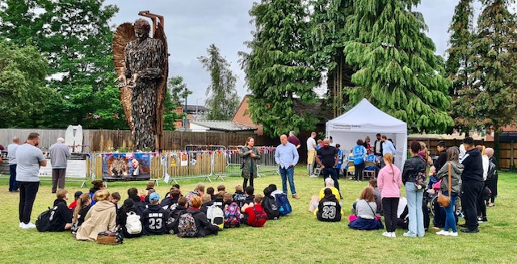
Mr and Mrs Freckleton and Danny Mondesir from Streetwhyze giving an education talk to school pupils.

Public Outreach Days drew lots of attention and were attended by several agencies on each day. The days were held on the 4th, 12th, 19th and 29th July in order to attract a varied attendance and were held on the grassed area of the Knife Angel site.
Services who took part were varied and included Staffordshire Fire and Rescue, Staffordshire Police, Lichfield District Crime Prevention Panel, LDC Parks team, Getin2it, Harmony, Pathways, Spark, SCVYS, James Brindley Foundation, StreetAid, Uniting Staffordshire Against Hate, West Midlands Air Ambulance Charity, Burton Albion Community Trust and the Henry Angel James Memorial Trust.

The public were encouraged to interact with the services, learn emergency first aid, do arts and crafts, and learn what its like to be in the emergency services.

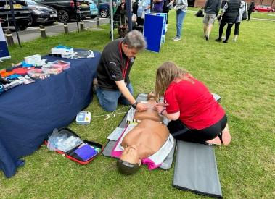
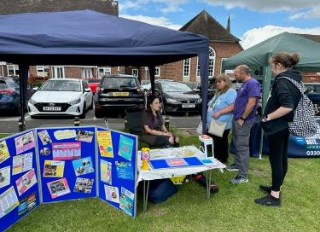
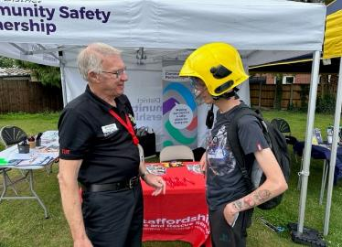
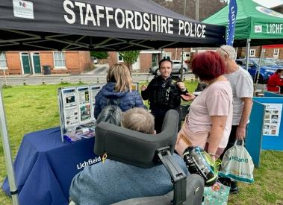
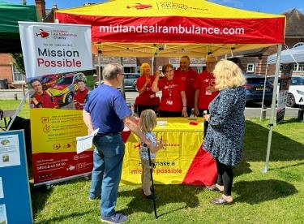
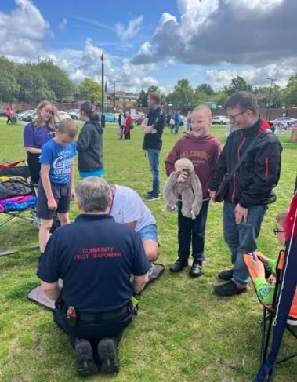
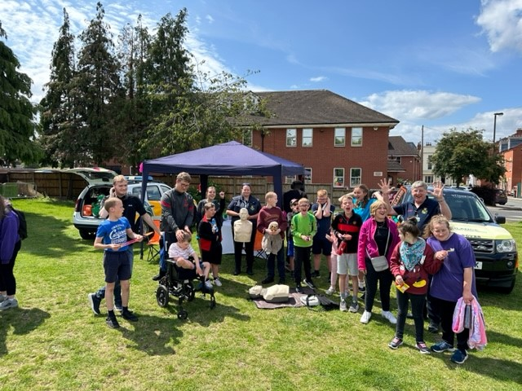
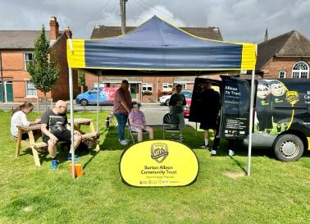

In addition to these Outreach Days the Air Ambulance Pod was in attendance over two days providing education and information about the air ambulance and how they respond to emergencies.
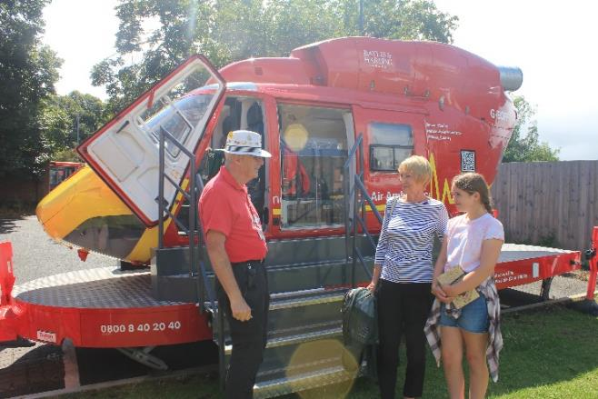

The Burton Albion Trust attended to engage with young people with their virtual reality goggles that the Violence Reduction Alliance are also now purchasing due to their success with young people.
The goggles place you as a young person in a scene with peers and the wearer is able to make choices and see how those choices affect the rest of the scene and lead to consequences. Consequential thinking is an area that schools and other education settings are working on with young people when it comes to violence, bullying and knife crime.

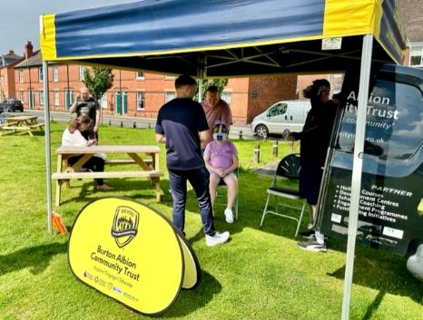
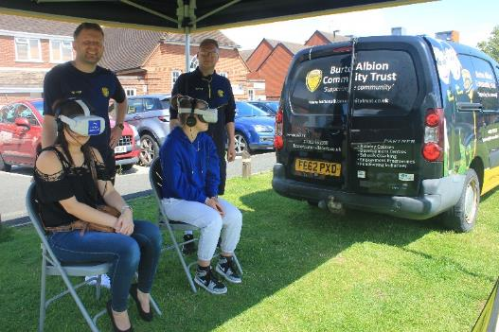

During July Lichfield Pride conducted their Pride march through the city and as a result of hate crime linking in with violence and violent crime the march ended at the Knife Angel Site where support services were present for the public to engage with. Over 200 people attended the site between 12noon and 2:30pm on Sunday 23rd July.

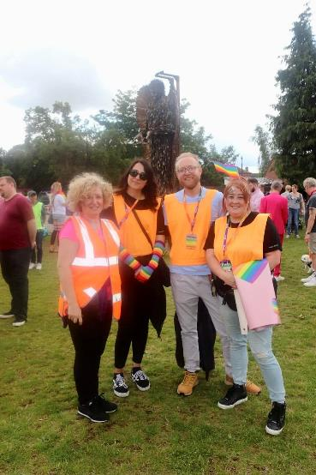
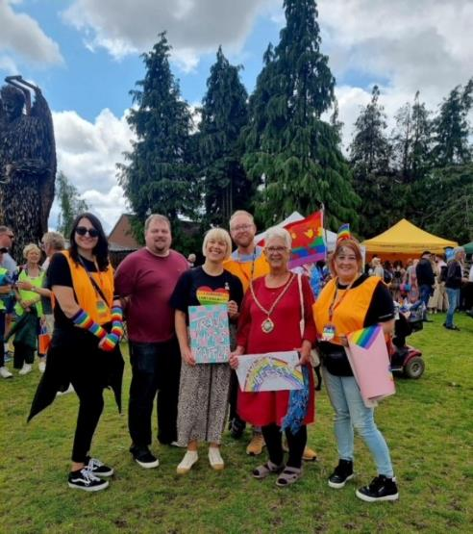

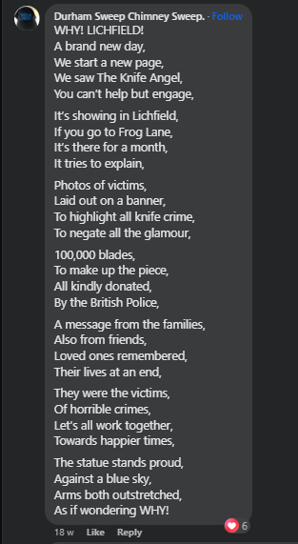
Art and Poetry

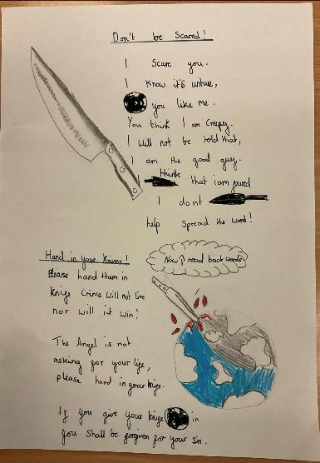
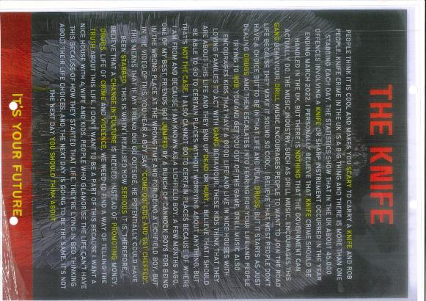

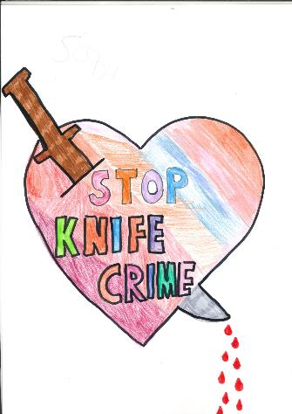
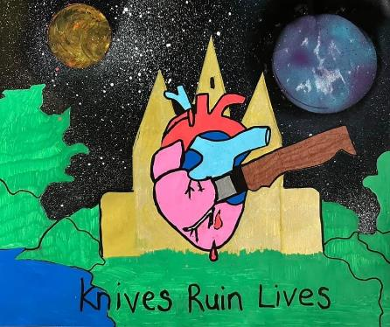
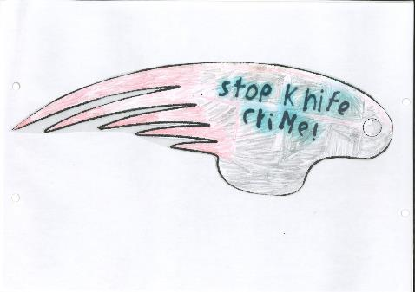

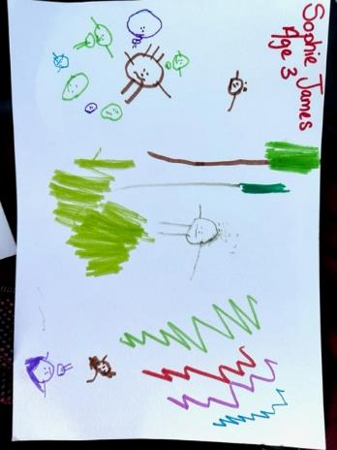
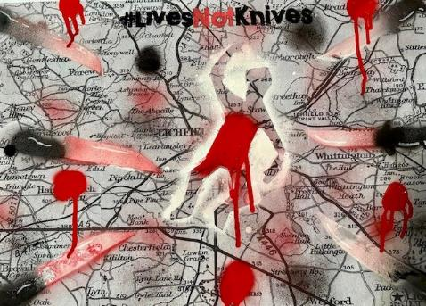
Examples of some of the art work and written words provided by local school pupils and a poem from a visitor.

Bleed Kits, Defibs and Training

Bleed Kits were not widely distributed across the District and in recent years the importance of
having bleed kits has been compared to the importance of having defibrillators – both being regarded now as an emergency first aid kit.

As part of the Anti-Violence Campaign the Community Safety Partnership funded twenty kits and arranged four sessions of training throughout July in locations in Lichfield and Burntwood.

The training was provided by West Midlands Ambulance Service and Mere Supplies and was given to a total of 101 people from various services and backgrounds including B & M, McDonalds, Three Spires shopping centre, Lichfield Cathedral, Lichfield District Council’s Customer Services, Staffordshire Police, Pathways, Civic Enforcement Officers, Burntwood Library, Burntwood Leisure Centre, Lichfield District Council Parks Team, Sports Development Officers, and The Lichfield Garrick Theatre.

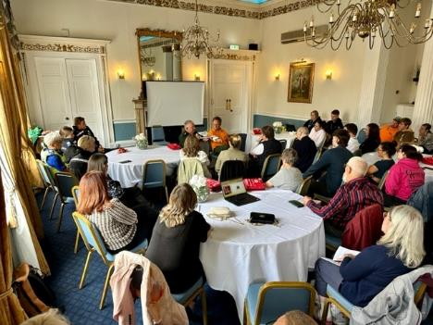
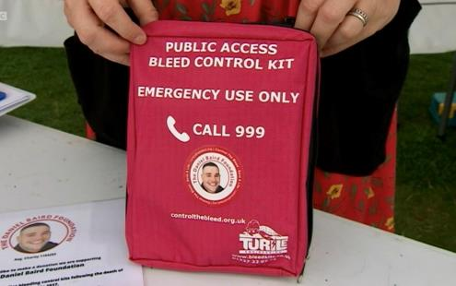
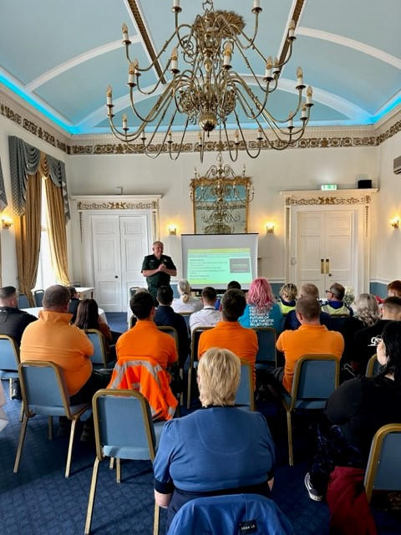

Each service took a bleed kit back to their place of work, starting what will become a populated mapping of bleed kits across the District.

With bleed kits and defibrillators being now regarded as on the same par in importance the Community Safety Partnership reviewed defib locations and with the City Centre Bird Street area being the location of highest reports of serious violence it was a surprise to see no defib reported as being placed there. Due to complications with building ownerships the nearest location that was identified that a defib could be placed at was B and M.
B and M were more than happy to have a defib and after some networking the Henry Angell- James Memorial Trust donated a defib to the campaign and this was fitted on the external wall of B and M. B and M’s bleed kit they obtained through training was placed in the box and a sign added to the box advising of a bleed kit also being available.

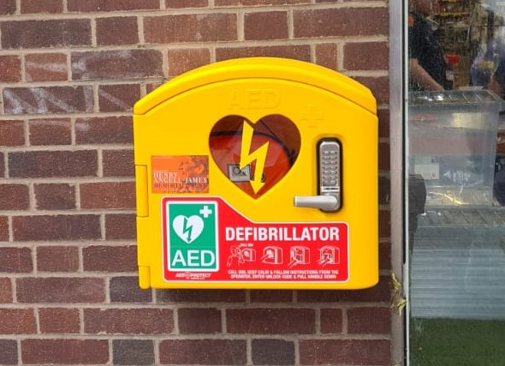

B and M Defibrillator just after it was fitted in Market Street

Staffordshire Commissioner for Police, Fire & Rescue and Crime, Ben Adams said:
“When someone is seriously injured, getting treatment to stop any bleeding as quickly as possible is vital.
“This bleed kit training session, delivered by the West Midlands Ambulance Service, is a really important way of giving local businesses the practical tools and knowledge, as well as the confidence, to potentially save a life if something happens in their workplace.”

Feedback from Attendees
Throughout the month over 7000 visitors attended the site and many gave their thoughts and reflections on the Knife Angel and the campaign.
This was done either in speaking with the Community Safety Partnership staff, other services present, completing the message cards and tying them to the fence, completing a quiz sheet or many chose to make posts on social media themselves.

‘I feel so moved by the Knife Angel.’’

‘Amazed by this great artwork.’’

‘’I feel sad and angry.’’
‘Very sad that knives have been used in crime.’’

“I feel inspired to educate and raise awareness.”

“Things like the Knife Angel should not have to be made, its so sad.”

“Great piece of artwork with a powerful message.”

“I feel sorry for all the families.”

Press & Social Media
The sculpture received high coverage both in the press and on social media.
It was good to see many media representatives at the site throughout the month, giving the Knife Angel’s visit and the important accompanying messages, the deserved publicity.

Additionally, articles and interviews were published during the visit, demonstrating how important this visit was to the District.

Below are some examples of coverage and posts from social media posts platforms:

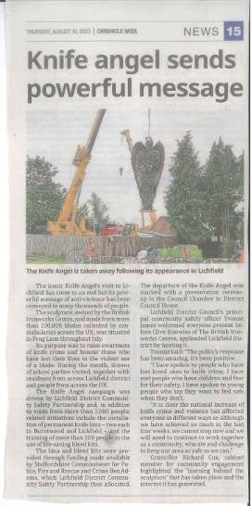
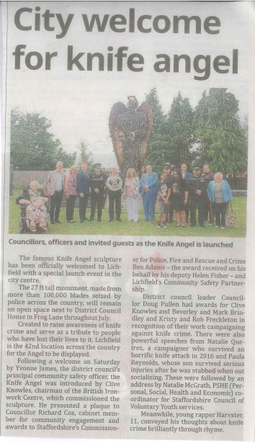


Two articles from Cannock Chronicle and Lichfield City Life magazine

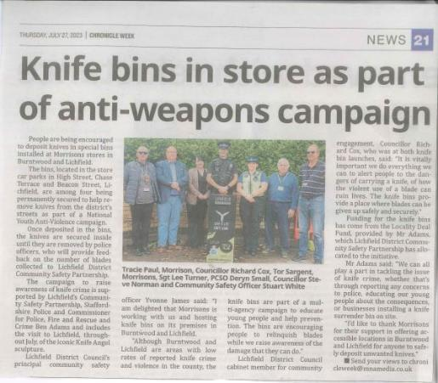
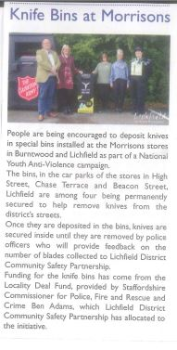
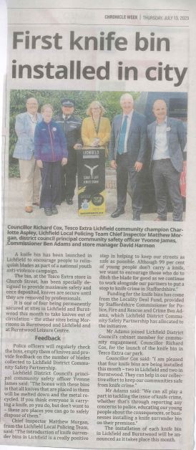

Articles from Cannock Chronicle and City Life Magazine.

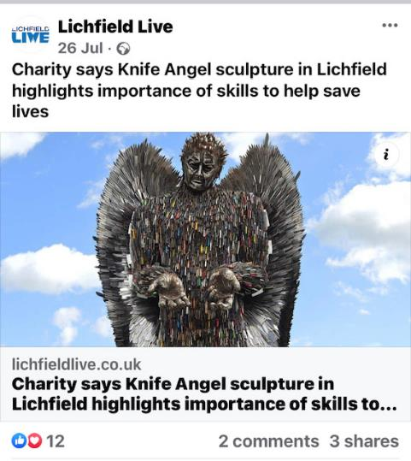
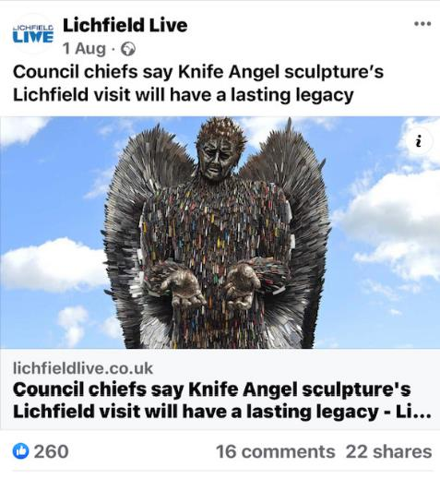

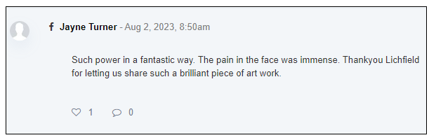
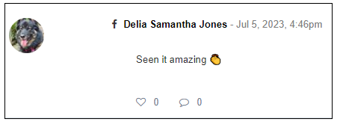
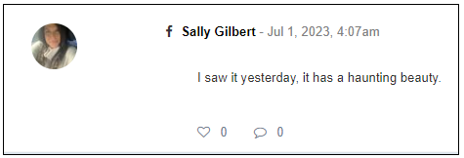
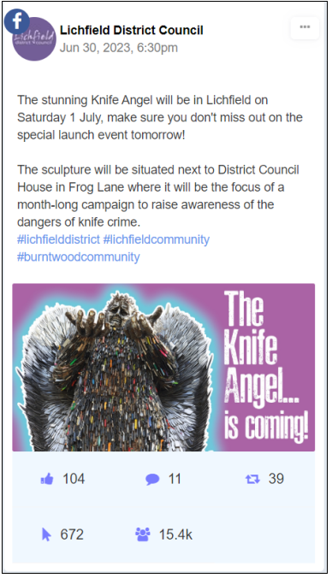

Articles from Lichfield Live

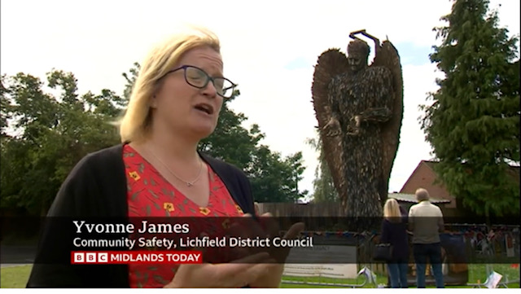

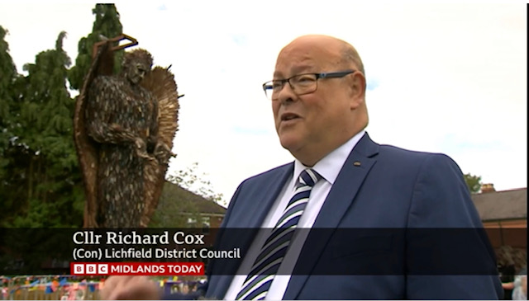

Screenshots from the BBC report that was aired on 30th July 2023 relating to the Knife Angel and campaigning

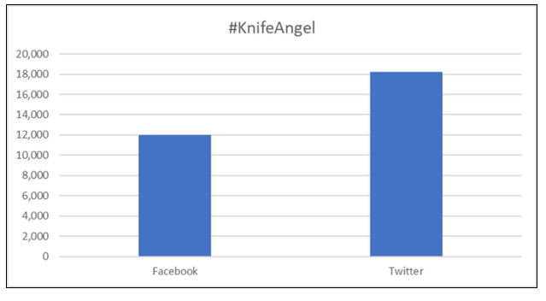

Comparison of reach between Facebook and X ( aka Twitter )

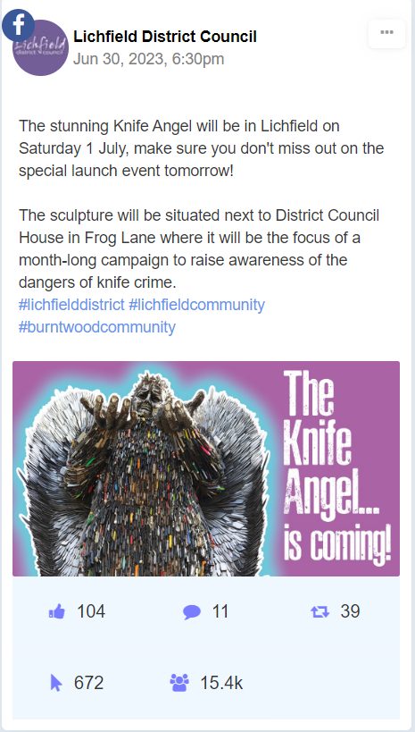
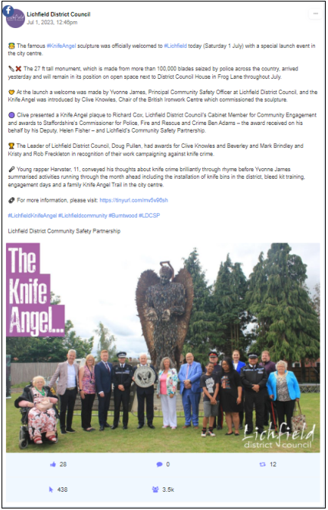

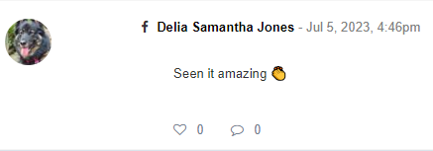

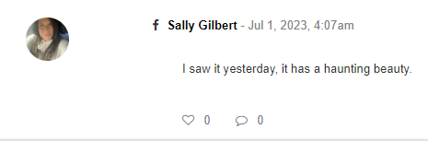

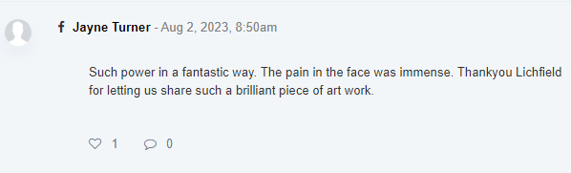

Closing Ceremony
On Sunday 30 July, a Closing Ceremony took place to mark the departure of the Knife Angel from the district.

The Ceremony was held at Frog Lane and was well attended with representatives from all key partners involved in the project, despite the inclement weather.

Yvonne James, Principal Community Safety Officer welcomed everyone to the event and asked Clive Knowles, Owner of The British Ironwork Centre to give a speech on the Knife angel. This was swiftly followed by an outstanding performance by Rapper Harvster.

Cllr Richard Cox, Portfolio holder for Community Safety also gave an impassioned speech on the profound impact he had felt in hosting the knife Angel and the lasting friendships he had made from those people involved.
A short speech and series of awards were them made Deputy Lord Lieutenant, Mr Johnny Leavesley to the following:

Two Rivers School | Directed most young people to Knife Angel Site and large involvement in project
Tesco | Knife Bin on their premises and providing Community Champion to support campaign
Morrisons | 2 knife bins at their stores
Burntwood Leisure Centre | Knife bin on site and providing space for Bleedkit Training, placing staff on bleedkit training and having a bleedkit on site
B & M | Supported campaign and supported Bleedkit training and taken Bleedkit. Accepted new Defib on building
Lichfield Cathedral | Supported campaign and supported Bleedkit training and taken Bleedkit. Also played an integral part in final procession at the departure event.
McDonalds | Supported campaign and supported Bleedkit training and taken Bleedkit.
The Garrick | Supported campaign and supported Bleedkit training and taken Bleedkit
Pathway Project | Supported campaign and supported Bleedkit training and taken Bleedkit. Also attended Knife Angel site for Community Outreach Day.

Beverley and Mark Brindley | Attended three Community Outreach Days, speaking to members of the public about their experiences. Have a successful foundation providing education and training.
Harvster | Inspirational young man who wrote raps on ‘ditch the blade’ campaign, performed 3 times over the course of the month.
Natalie Quiroz | Victim of knife crime who actively engages with schools and public. Campaigns against knife crime.
Paula Reynolds | Son was a victim of knife crime, she actively engages with schools and public. Campaigns against knife crime.

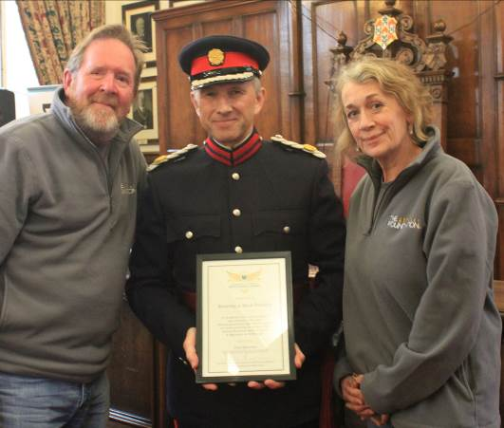

Mr and Mrs Brindley receiving their award from Deputy Lord Lieutenant Mr Johnny Leavesley

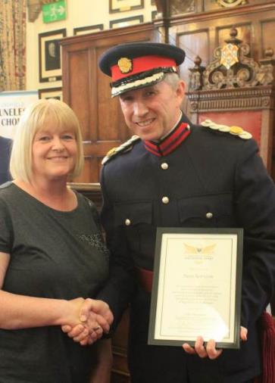
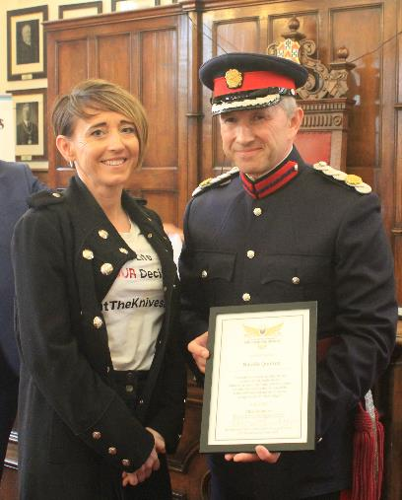
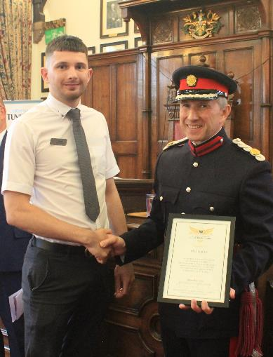

A representative from McDonald, Paula Reynolds and Natalie Querioz receiving their awards.

The closing ceremony also included a walking procession of remembrance through the city centre which started from the Council house and ended at the Cathedral.
Mark Brindley was offered the Beacon of Hope torch to lead the procession which went through the streets of the city, the procession paused at the new defibrillator on Market Street where Sally Angel James cut the official opening ribbon and spoke about the importance of emergency first aid, to then continue the procession to the Cathedral where the Dean was waiting to say a blessing in memory of those who have lost their lives to violent crime.

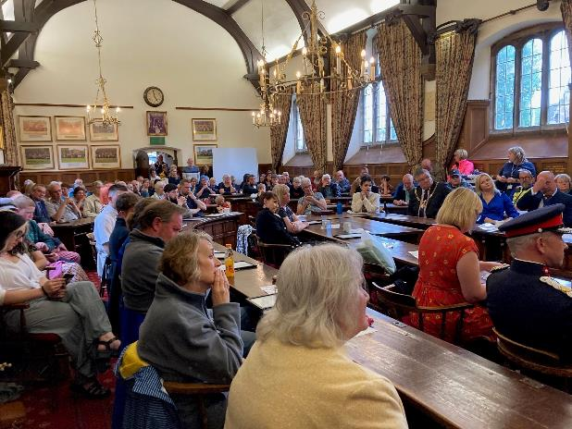

Crowd at the Closing Ceremony listening to Cllr Richard Cox

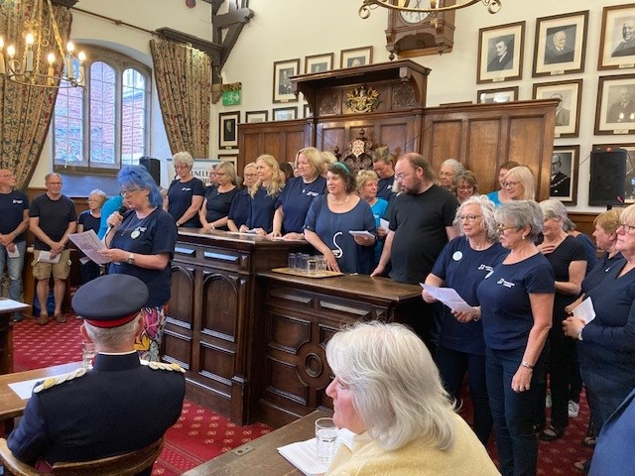

Lichfield Tuneless Choir sang Something Inside So Strong bringing some attendees to tears.

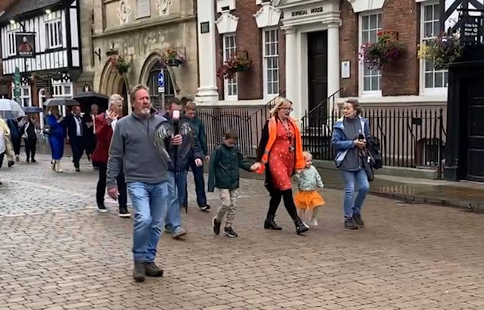

Procession going along Bore Street lead by Mr Brindley with the Beacon of Hope

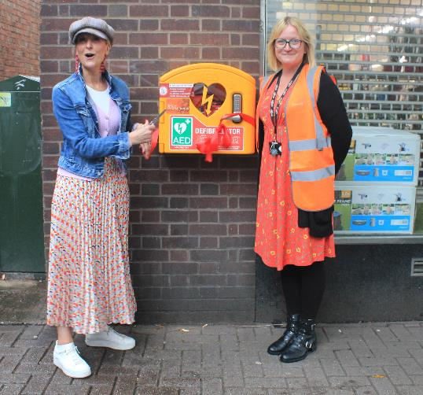

Sally Angel James and Principal Community Safety Officer Yvonne James at the ribbon cutting of the defibrillator.

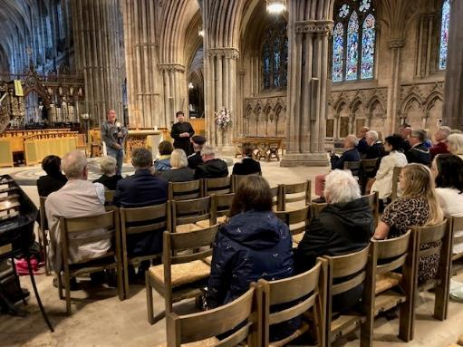
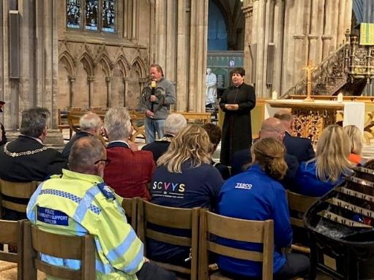

The blessing being given by the Dean in Lichfield Cathedral

Knife Amnesty
As part of the National Anti-Violence Campaign knife amnesties play a large part.

As a result the Community Safety Partnership funded four Knife Bins to be placed around the District.
Thanks go to Tesco, Lichfield, Morrisons, Lichfield and Burntwood and Burntwood Leisure Centre for hosting the Knife Amnesty Bins, which are now in permanent situ.

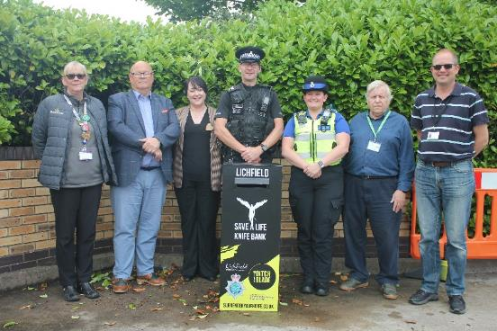
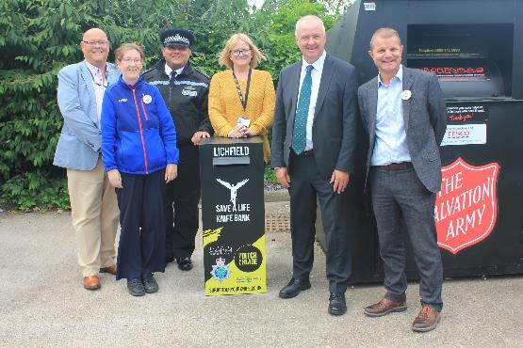

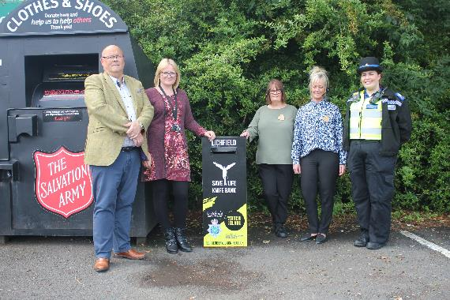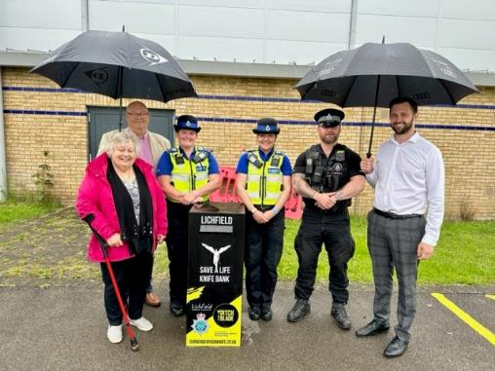

The Knife Bins are to be emptied frequently by Staffordshire Police and stored at the Lichfield Police facility where once a year they will be provided to the British Ironwork Museum in Oswestry for the metal to be melted down, ensuring that these knives will never be back out in circulation to be able to be used for crime.

Each bin was put in place and officially opened throughout July and all were emptied by Police after 12 weeks of being in place, resulting in almost 300 blades and a firearm being retrieved for safe disposal.
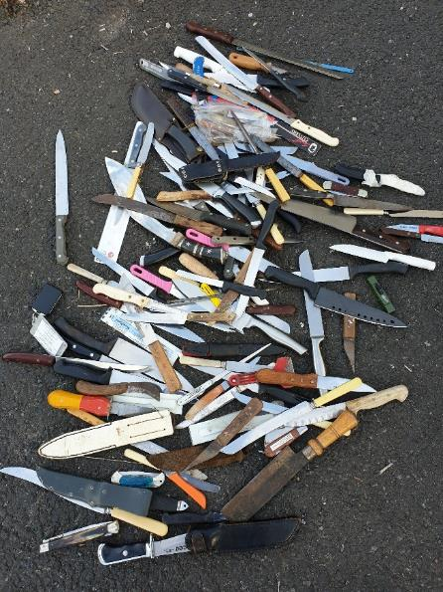

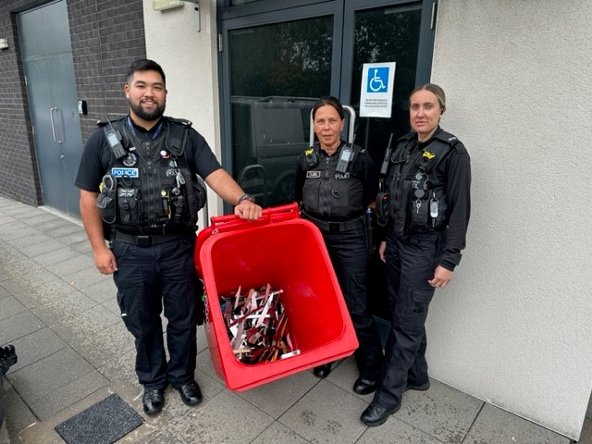

Chief Inspector Matthew Morgan, from the Lichfield Local Policing Team (LPT), said:
“The introduction of knife surrender bins in Lichfield is a really positive step in helping to keep our streets as safe as possible.
“Although 99 per cent of young people don’t carry a knife, we want to encourage those who do to ditch the blade for good as we continue to work alongside our partners to put a stop to knife crime in Staffordshire.”

Summary of Campaign Stats

Recorded Visitors to the Knife Angel Site | Over 7000
Pupils educated on site in school / education visits | 1070
Pupils educated within schools having assemblies with Alison Cope | 1200
Number of people to have completed a Knife Angel Education Quiz on site | 1112
Number of people who did the Knife Angel Trail through the city | 135
Number of messages written and tied to the fencing around the Knife Angel | 1176
Number of people trained in the use of bleed kits | 101
Number of bleed kits distributed across the district | 19
Number of Knife Bins funded and placed in District | 4
Number of Knives in bins after 12 weeks | Almost 300
Pieces of artwork produced and submitted | 82
Young people awarded certificates for their artwork | 10
Young People awarded certificates for their poetry/song writing | 2
Votes made towards the art competition | 1057

Legacy

Increased awareness
Multiple organisations held sessions throughout the month-long engagement programme, ensuring increased awareness through collaboration. This approach allowed all ages, especially young people, to stand up against violence and aggression in all forms, not just knife crime.

Increased Visitors
It is estimated that over 7000 individuals visited the sculpture across the month, both during the day and at night. Although no official figures have been recorded, it was identified that many were specifically travelling to the well-known tourist destination to see the Knife Angel.

Legacy Rose Planting

On 22nd and 23rd November 2023 the David Austin Lichfield Angel roses that were planted in
pots around the foot of the Angel in July will be planted in the grounds of Beacon Park and Chasetown Memorial Park in remembrance of the campaign and the ongoing challenge that tackling violent crime is. Press releases are arranged for this.

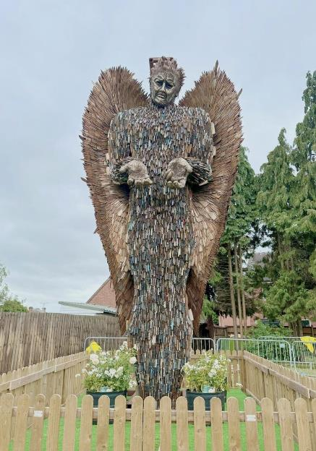

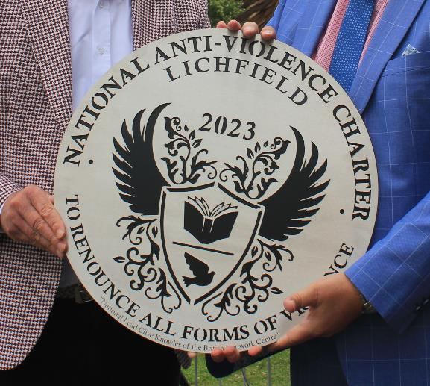

Commemorative Plaque

The commemorative plaque that was presented to the District by Clive Knowles at the launch
event will be positioned in a central location within the city.

Bleed Kits and Training

The bleed kits and training was well received across the district but it is clear that more needs
to be done with regard this life saving piece of equipment and the still many areas of the district without a kit in prime locations. The CSP would like to fund more kits in the next financial year
and arrange more training across the district.

Pledges and Messages

The 1176 messages that were tied to the fencing have been kept safe and in the new year plans
will be made to decide how best to move forward with them and how they can be displayed
to show the impact the Knife Angel had on the community.

Future Education for the Districts Schools

The Training Initiative who run StreetAid and the James Brindley Foundation are currently
planning a pilot education programme that can be ran in both primary schools and secondary schools with a particular focus on ensuring the same message is being delivered to all. This has been requested by the Community Safety Partnership and Cllr Richard Cox with the hope that these local services will be delivering these in future.




Clive Knowles :
“There are a lot of towns and cities across the UK that are not as courageous as Lichfield has been in dealing with these social issues.
“So, I am proud of Lichfield. It is a leading light for towns and cities of this sort of size. I salute you for being so brave.”

Principal Community Safety Officer Yvonne James:
“The public’s response has been amazing, it’s been positive, and many have approached us on site and just said ‘thanks so much for doing this as it’s so important’.
“I have spoken to people who have lost loved ones to knife crime, I have met people who have children and fear for their safety, I have spoken to young people who say they want to feel safe when they don’t.
“It is clear the national increase of knife crime and violence has affected everyone in different ways so although we have achieved so much in the last 4 weeks, we cannot stop now and we will need to continue to work together as a community, educate and challenge to keep our area as safe as we can.
“I would like to thank all who have been involved and supported this campaign, particularly the members of the Lichfield District Community Safety Partnership – we cannot achieve such success in isolation, only by working together.”

Future Partnership
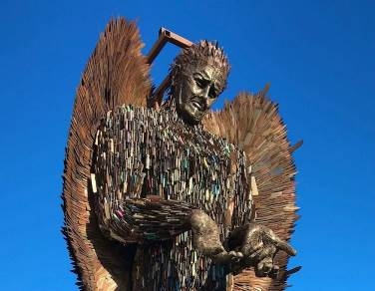
The month-long engagement programme saw a lot of partnership working and networking. Relationships and contacts made as a result of this project will continue to evolve following its completion….

