Make life simpler: pay by Direct Debit  - Never miss a payment  - Quick and easy to set up  - Protected by the Direct Debit guarantee  Sign up at www.lichfielddc.gov.uk/businesspay |  | Register for a My Account online  - Paperless billing  - Check your balance  - Access your account any time  Sign up at www.lichfielddc.gov.uk/businessrates
Important information about making a business rates payment
We will set up instalments for you to pay your business rates over ten months (April – January). To request to pay them over 12 months, you need to write to us by 10 March. If you don’t pay by Direct Debit, please remember to pay by the 1st of each month, or we will send you a reminder.

If you pay by debit or credit card at www.lichfielddc.gov.uk/pay, or using our 24-hour automated payment line on 0345 234 0068, you will need your business rates reference number (shown on the front of your bill).

If you pay at a PayZone, PayPoint or Post Office, you’ll need to take this bill with you as it has a barcode on it which needs to be scanned. These payments take up to 5 working days to reach your account.
Are you claiming everything you are entitled to?  Whether you are a small business, a business operating in the retail, hospitality or leisure industry, or are a charitable organisation, you could be eligible for a reduction in your business rates bill.  Visit www.lichfielddc.gov.uk/businessrates for information about business rates reliefs and exemptions, the business rates explanatory notes, along with an explanation of how your business rates are calculated and spent. You can request a hard copy of this information by writing to us at the below address.  If you need advice on the reliefs or exemptions your business might be entitled to, please contact our customer services team on 01543 308000, Monday – Friday, 9am - 5pm or WhatsApp us on 01543 308171 at any time. |  |  | 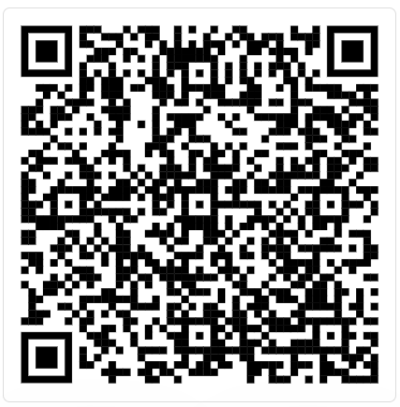  Scan the QR code to find out about business rates relief your business might be able to claim and find out how to apply
Contact us and supporting you  The quickest and easiest way to contact us is online at www.lichfielddc.gov.uk/businessrates where you can sign up for a business rates account, let us know when you’ve moved, apply for reliefs and exemptions, view your account balance and more, or you can write to Revenues & Benefits, District Council House, Frog Lane, Lichfield WS13 6YX.  If you need help or support, including if you are struggling to pay your bill, please contact our customer services team on 01543 308000, Monday – Friday, 9am - 5pm or WhatsApp us on 01543 308171 at any time. |  |  | 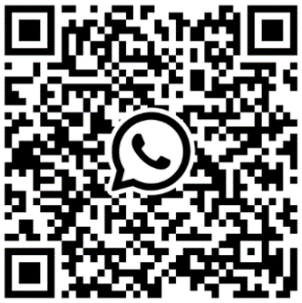  Scan the QR code to Whatsapp us
Data protection (GDPR)
The law allows us to process your ordinary personal data either because it is necessary to do so to perform a task carried out in the public interest, or in the exercise of official authority vested in us. Please read our privacy notice at www.lichfielddc.gov.uk/rbprivacy on how we use your data and who we may share it with. A paper copy is available on request.

